Montreal’s artificial intelligence (AI) cluster:
Looking for a winning financial strategy!

Introduction

It was late April afternoon and Patricia Amacifuen Vilchez was rushing along the busy streets of downtown Montreal to a meeting with Montreal International and Investissement Quebec. Montreal International is Greater Montreal’s economic development agency for foreign investment, international organizations and strategic talents. Investissement Quebec is an organization that helps to attract investment in Quebec by Canada-based and international companies.

Photo: Patricia Amacifuen Vilchez

Patricia, a master’s student at HEC Montreal, was doing a joint project with these two organizations with regard to analyzing the financial situation in Montreal’s AI sector and comparing it to the major AI hubs across the globe. It was her second project with these partners. The first report was related to a branding strategy for Montreal’s artificial intelligence hub, which she had already successfully finished and presented last winter. Her work was so appreciated that she was invited to work on a second report, this one relating to the Montreal AI hub’s financial strategy. She was going to report on the results of her work at the preliminary meeting today, and she could not wait to share her insights.

Montreal’s AI hub

It has been argued that clusters have important effects on local economy and innovation, because firms benefit from a specialized and flexible labour market, specialized suppliers in all phases of the productive chain of a good, as well as easy availability of skills in regional agglomerations (Boix and Galletto, 2009, Porter, 1998; Keeble and Wilkinson, 1999; Mudambi and Swift, 2012). Technology-intensive and knowledge-intensive activities tend to be more geographically concentrated than other types of activities (Brewer et al., 2003). Recent studies also emphasize socially-driven mechanisms in clusters, such as networking among firms, universities, regional authorities, and research institutions, that ensure collaboration and enable the sharing of resources and knowledge (Turkina et al, 2016; Turkina and van Assche, 2018; Turkina et al, 2019).

Montreal has become a major global hub for artificial intelligence (AI) research, and its AI ecosystem is thriving. The city boasts an exceptionally high concentration of expertise in the area of AI, thanks in part to the efforts of University of Montreal’s professor Yoshua Bengio, the head of the Montreal Institute for Learning Algorithms (MILA), as well as to the work of professors at McGill University’s Electrical Engineering and Computer Science Department. Together with Geoffrey Hinton (Toronto) and his student Yann LeCun (educated in Toronto, now working in NYC), Yoshua Bengio is considered one of the three fathers of deep learning, an important subset of AI. In 2019, these three scholars received a Turing prize, which is the equivalent of Nobel prize in computer science. Many called this event the victory of Canadian AI education.

According to SAP Analytics (2018):

- AI “works by combining large amounts of data with fast, iterative processing and intelligent algorithms, allowing the software to learn automatically from patterns or features in the data. AI is a broad field of study that includes many theories, methods and technologies.”
- Major subfields of applications are: machine learning, neural network, deep learning (complex patterns in large amounts of data and common applications include speech recognition), cognitive computing, computer vision and natural language processing (NLP).
- Artificial intelligence needs support from other technologies, such as graphical processing units, the Internet of Thins (IoT), advanced algorithms and application processing interfaces.
- AI is applied to many industries. The most popular ones are: finance, logistics, health care, retail, manufacturing and sports.
As far as Montreal is concerned, McGill University and University of Montreal have more than 250 researchers and doctoral students in deep learning, making it the largest AI academic community in the world. Montreal has also very famous researchers in automatic speech recognition, neuroscience, computer vision, electrical engineering, natural language processing and reinforcement learning. The city offers very strong undergraduate and graduate programs in these fields.

In addition to very strong research and education in AI, Montreal boasts a dynamic industrial community with over 250 start-ups and major industry leaders—international giants—that all came to Montreal in recent years to establish AI research labs, including DeepMind, Facebook, Google, Microsoft, Samsung and Thales. Local start-up Element AI (co-founded by professor Yoshua Bengio and a group of tech entrepreneurs in 2016) quickly became the largest private R&D lab in the world, and today employs around 500 people and is opening labs across the globe, namely in London, Singapore, Tokyo, and Toronto.

Montreal is not the only advanced AI hub in Canada: Principally Toronto, but also Waterloo and Edmonton share that distinction. While Toronto has a bigger start-up community, Montreal has more research labs and has stronger research capabilities. In general, Montreal is considered to be number one in deep learning research, surpassing even strong competitors as Silicon Valley, London and Boston-New York agglomerations. Figure 1 below reflects the major hubs and major AI research actors in Canadian AI and Figure 2 focuses specifically on Montreal. Its start-up section indicates the major areas of hub’s specialization.
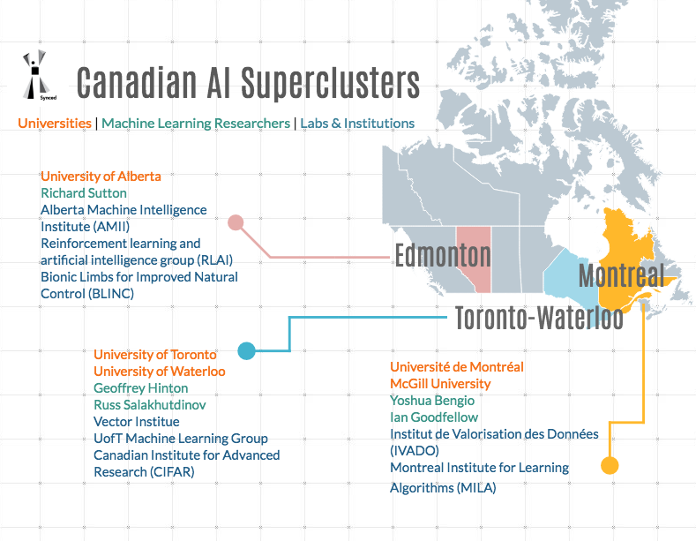
Figure 1: Building AI Superclusters in Canada. Retrieved from Synced. (2018).
https://medium.com/syncedreview/building-ai-superclusters-in-canada-4444c588f1ff
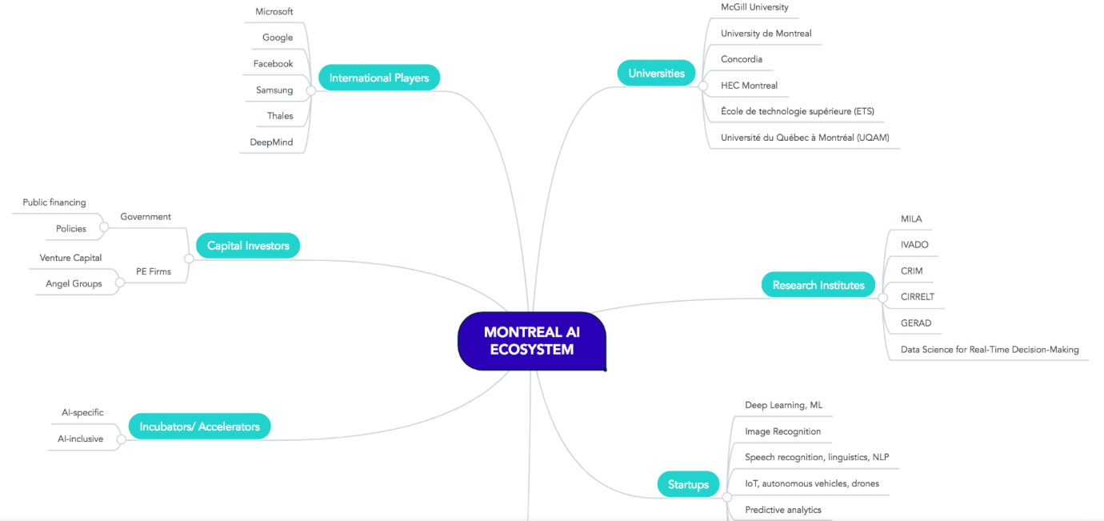

Figure 2: Canada’s Artificial Intelligence Ecosystem — Montreal. Easton, L. (2018). Retrieved from https://medium.com/believing/canadas-artificial-intelligence-ecosystem-4798b0517016

Investments in Montreal and Canadian tech and AI

In recent years, Canada has become a fast-growing, global tech and innovation centre. Studies show that a record $447 million CAD of venture capital has been injected into Canadian AI start-ups between 2015 and 2017.
In 2017, the Government of Canada challenged Canadian businesses of all sizes to collaborate with other innovation actors, including post-secondary and research institutions, to propose bold and ambitious strategies that would transform regional economies and develop job-creating superclusters of innovation, such as Silicon Valley. The government also made other huge investments in the $125-million Pan-Canadian Artificial Intelligence Strategy administered by the Canadian Institute for Advanced Research (CFAR), which works in partnership with three AI institutes: the Alberta Machine Intelligence Institute (Amii) in Edmonton, MILA in Montreal and the Vector Institute in Toronto. The Strategy has four major goals:

- To increase the number of outstanding artificial intelligence researchers and skilled graduates in Canada.
- To establish interconnected nodes of scientific excellence in Canada’s three major centers for artificial intelligence (Edmonton, Montreal and Toronto).
- To develop global thought leadership on the economic, ethical, policy and legal implications of advances in artificial intelligence.
- To support a national research community on artificial intelligence.

Montreal has received $40 million from the Pan-Canadian Artificial Intelligence Strategy, as well as $100 million from the Government of Quebec over five years for the creation of an AI hub. The Canadian federal government is also investing over $950 million under the Innovation Superclusters Initiative. The investment is expected to create more than 50 000 middle-class jobs and grow Canada’s economy by $50 billion over the next 10 years. Montreal’s artificial intelligence cluster SCALE AI is one of the winners of this supercluster initiative, receiving $290 million in funding. In sum, a lot of money is flowing into Montreal’s AI sector. The Government of Quebec has also announced a $60-million financial contribution to support the activities of SCALE AI and its IVADO LABS laboratory, an organization created to provide support and guidance to companies in implementing projects developed as part of the supercluster.

Moreover, McGill University and University of Montreal received $84 million and $93.5 million respectively from the $900-million Canada First Research Excellence Fund to pursue their AI-related research. These universities also received a lot of private funding from tech giants such as Microsoft, Google and Facebook for joint AI research.

- In 2016, Google gave $3.33 million USD over three years to MILA
- In early 2017, Microsoft contributed $7 million USD to McGill University and University of Montreal’s AI Labs
- In August 2017, MILA was awarded $2.4 million USD research grant from the US-based Open Philanthropy Project, to make AI safer for society
Additionally, Montreal has enjoyed considerable investments in adjacent fields. For instance, in the 2014-2017 period, the city invested $563 million in smart city initiatives (Projet Montréal, 2017). In 2016, the city launched Capital Intelligent Mtl, a group of 23 venture capital firms, financial institutions, and corporations. Capital Intelligent Mtl helps arrange vital financial backing for innovative tech companies, offering solutions for present and future urban challenges. Funding is available both for start-ups and established businesses wishing to grow their operations. If a company or an entrepreneur has ideas to develop tech urban solutions and help make Montreal a global leader among the world’s smart cities, Capital Intelligent Mtl can put them in contact with some of the most influential players in the field. Capital Intelligent Mtl has $100 million in capital earmarked for smart city projects.
Montreal has a lower GDP per capita, but higher tax rates than Toronto and major US cities. Therefore, greater efforts are required to attract international investment and enhance economic growth. The mayor of Montreal, Valérie Plante, decided to invest an additional $360 million in business and entrepreneurship in Montreal over the next four years to bolster Montreal's economy.

It is also important to note that in addition to efforts to grow local entrepreneurship, Montreal also counts on the role of international investors in its economic development—big multinational firms such as Google, Pratt and Whitney, Facebook, as well as venture capitalists and various international foundations. Organizations like Montreal International and Investissement Quebec work hard to help attract international investors. As far as AI industry is concerned, major industry players opened AI research labs in the city over the last three years, including DeepMind, Facebook, Google, Microsoft, Samsung and Thales.

Montreal has important cost advantages appreciated by international firms. It costs less, on average, to operate a business in Greater Montreal than in any other large metropolitan region in Canada and the United States, without even counting the very attractive incentives that are available.
- An average cost advantage of over 20% in high-tech sectors
- Highly competitive salaries in the tech sector
- Subsidies and interest-free loans for major and innovative projects
- Up to a 30% tax credit on R&D costs
- Sectoral tax credits of up to 43%
- Electricity rates as low as 3.98¢CAD/kWh for large power customers

At the same time, in comparison to the neighboring US, Canada has a fewer number of venture capital investors. Therefore, a lot of Montreal start-ups receive funding from Silicon Valley investors. For instance, in 2017, Element AI attracted an unprecedented number of investments, totaling over $130 million, the largest amount in AI history for series A round of funding. The majority of these investments came from Californian investors (Figure 3).

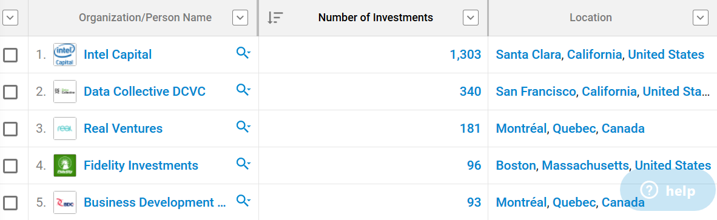

Figure3: Investments in Element AI, series A round of fudning

One of the most important Montreal’s investors is Real Ventures. The organization posted on their website:

“Created in 2007, the organization questioned why brilliant Canadian founders should have to jump on a flight to SF to raise seed capital. We also believed that VCs (venture capitalists) should play a role in accelerating the creation of world-class tech ecosystems by providing support beyond the companies for whom they wrote cheques, so we rolled up our sleeves and built projects that served founders’ needs. Fast-forward 10 years and Real Ventures has invested in over 200 companies, grown a network of 1000+ founders, raised over $300M across 5 early-stage funds, witnessed Canada’s transformation into the home of multiple top-20 global tech hubs, and seen the Valley’s best VCs jumping on flights from SF & NY to Canada to back industry-defining companies.”

Therefore, Real Ventures is working hard to improve Canada’s investment climate. What’s more, according to Business Development Bank of Canada, there are between 20 000 to 50 000 angel investors (individuals who provide capital for business start-ups, usually in exchange for convertible debt or ownership equity) in Canada. It is important to do more work to involve these investors into funding AI.

In general, analysts note a change in funding for Canadian AI. According to JF Gagné, the CEO of Element AI, on average, the last 5 years (as of Q1 2018) saw a 49% increase in AI-related deals. At the same time, the nature of these deals is evolving. Venture/angel-backed deals have dropped from 55% in 2013 to 36% today: “AI businesses that were previously focused on technology are now in the process of commercializing: talking to their client bases to figure out how foundational AI technology (…) can solve problems in existing businesses.” Meanwhile, corporate actors have doubled their number of deals, and accelerators and incubators have tripled theirs. Canadian investors sign most of these deals (62%), and international investors have kept a stable share of about 40% across the last five years.

Continued funding from local investors has kept powering the start-up community and has bolstered the credibility to the ecosystem, making it a prime target for international investors. This is evidenced by the multiple $100M+ deals that have happened in Canada in the last few years.

It is also important to mention that the number of acquisitions is on the rise by an average of 50% in the last five years, and they are made mostly by international actors (primarily from Silicon Valley).

The trend toward continued acquisition and international investment demonstrates that Canadian start-ups are continuing to attract international attention, and that the ecosystem is moving from being in an activation phase towards being in a globalization phase (or expansion for the bigger cluster cities). Figure 4 below presents the funding amount and the number of deals.

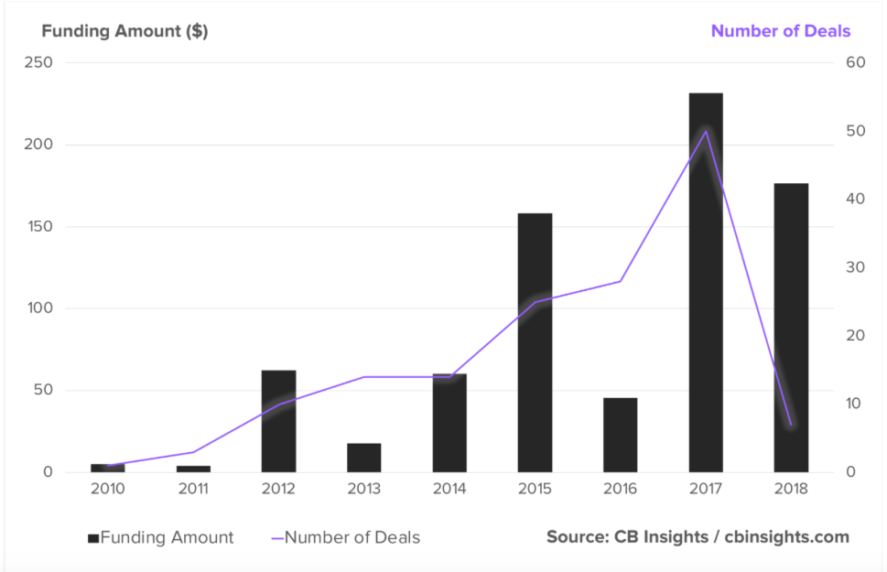

Figure 4: Gagné, Jf. (2018). Canadian AI Ecosystem. Retrieved from http://www.jfgagne.ai/blog/the-canadian-ai-ecosystem-in-2018

In sum, there are four major sources of funding for tech agglomerations:
1) Government-based financing tools
2) Government support programs such as tax credits
3) Public-private partnerships
4) Private funding

At the same time, different AI hubs show different financial strategies. There are a few examples below of how different locations approach this issue.

Financial situation in other AI hubs

Figure 5 presents the size of financing received by AI firms by country.

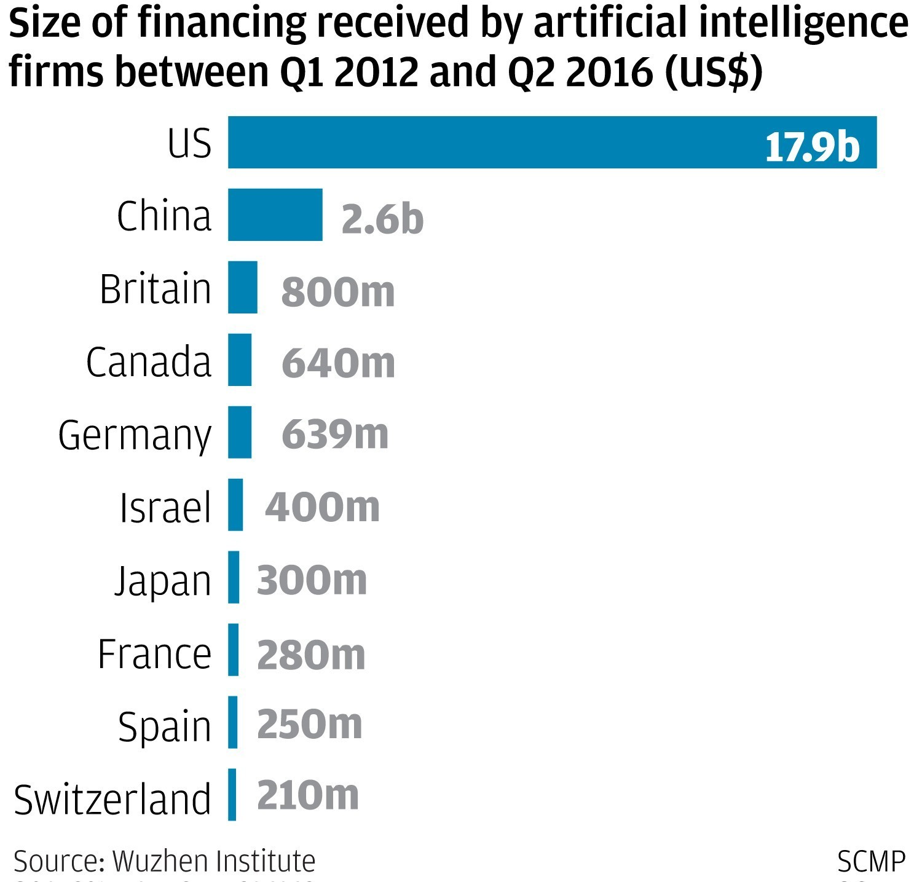

Figure 5: Financing of AI firms across the globe

Figure 5 indicates that US firms enjoy the highest amount of investments, followed by Chinese and UK firms. Canada is fourth on the list.

Toronto

Similarly to Montreal, Toronto has also benefited from investments allocated in the framework of the Pan-Canadian Artificial Intelligence Strategy. At the same time, the Toronto hub has relied more heavily on private funding. While Montreal has been traditionally the strongest hub in the world in research, the Toronto region has the highest concentration of AI start-ups in the world. It is home to different AI institutions and initiatives such as the Vector Institute, NextAI, and the Creative Destruction Lab. Google, Thomson Reuters, TD Bank Group, Shopify and 26 more companies have committed a combined total of over $80 million over 10 years to support Toronto’s Vector Institute led by Jeffrey Hinton, one of the three fathers of AI (together with Montreal Yoshua Bengio and NYC Yann Le Cun). In the past year, there were more new tech jobs added in the Toronto Region than New York City and the San Francisco Bay Area combined. In terms of job numbers, the Toronto Region has surpassed Boston, Chicago and Seattle.

Recent investments in Toronto:

- 2019: Adobe Systems Inc. is the latest foreign technology giant planning to open an AI lab in Toronto. The Silicon Valley software giant, best known for document-creation products Photoshop and Acrobat, says it is looking for a Toronto-based AI lab director to “establish a cutting-edge research lab in artificial intelligence, that will both push the state-of-the-art and have a profound impact on Adobe’s products,” according to a job posting on LinkedIn.
- 2019: The Redmond, Wash., software giant announced plans to build massive new Canadian headquarters in Toronto, promising to invest $570 million in the facility.
- 2019: Microsoft expects to move into the new facility, located at 81 Bay Street, in September 2020. The company will relocate its current Canadian headquarters and several other offices, dispersed through the country, to the new headquarters.
- 2018: Uber announced plans to invest more than $200 million in Toronto over five years as it opens an engineering office and expands its self-driving car centre. In 2017, the company also announced a new research hub to focus on developing AI for driverless vehicles, representing Uber’s first R&D operation outside of the United States.
- 2018: NVIDIA announced plans to open an AI research facility to further explore novel approaches to deep learning. The team will be led by deep learning, computer vision expert and University of Toronto assistant professor Sanja Fidler.
- 2018: Etsy chose Toronto as the location for its newest Machine Learning Centre of Excellence, the first in Canada.
- 2018: Samsung opened a new R&D office which focuses on strengthening collaborative research with world-leading scholars in the AI field.
- 2017: OpenText’s new flexible AI platform combines open source machine learning with advanced analysis to acquire, merge, manage, and analyze big data.
- 2016: Thomson Reuters opened a new “Toronto Technology Centre” to house their cognitive computing activities. The decision was driven by the region’s technology strengths in data visualization and artificial intelligence.
- 2016: General Motors committed to growing its engineering workforce in Markham to 1 000 to focus on autonomous vehicle software.
Europe

In Europe, the most advanced AI hubs are located in UK, Germany and France (Figure 6). Figure 7 presents best funded AI companies in Europe.
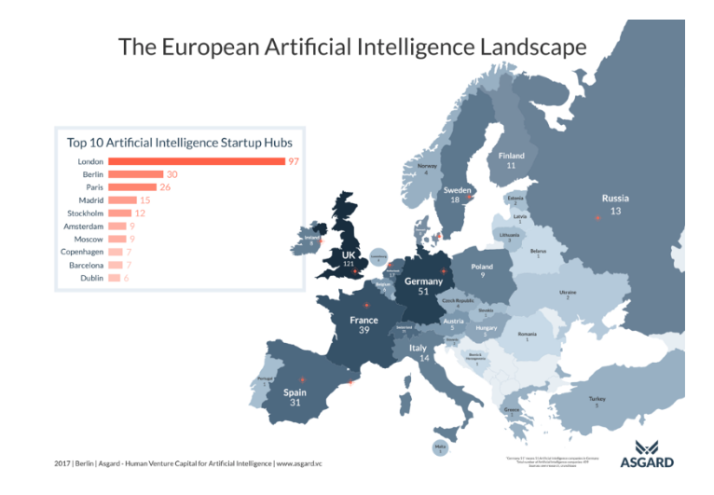
Figure 6: City AI. (2017).The European Artificial Intelligence Landscape . Retrieved from https://medium.com/cityai/the-european-artificial-intelligence-landscape-more-than-400-ai-companies-build-in-europe-bd17a3d499b
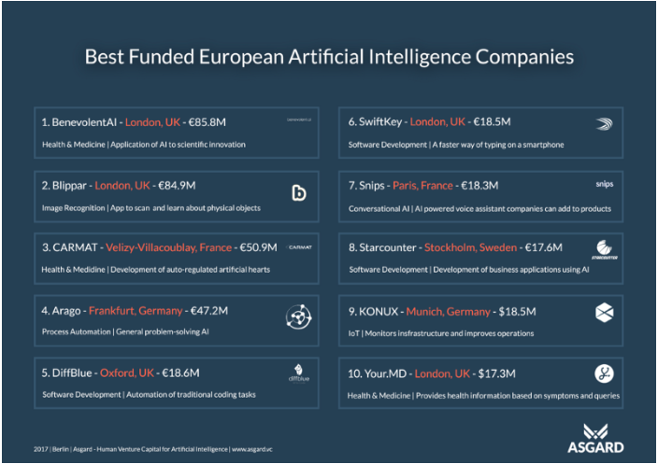
Figure 7: City AI. (2017).Best Funded European Artificial Intelligence Companies . Retrieved from https://medium.com/cityai/the-european-artificial-intelligence-landscape-more-than-400-ai-companies-build-in-europe-bd17a3d499b

London

The UK government has set aside £3 million for projects designed to boost productivity in financial and legal services using artificial intelligence. Research commissioned by the Department for Business, Energy and Industrial Strategy will focus on improving AI technology to reduce processing times across services while saving money for consumers. The projects will be supported by the department’s Industrial Strategy Challenge Fund, which aims to bring together businesses with research to boost innovation in the UK. The research will begin in December and run for three years. Key areas of interest for the projects—which will take place at the University of Oxford, Loughborough University and the University of Sheffield as part of the Next Generation Services challenge—will be applications for claims processing in the insurance sector as well as speeding up legal cases.

London is also establishing a reputation as a global artificial intelligence (AI) hub, with investors flocking to the city. New research from Pitchbook, seen by CNBC, revealed that between 2015 and 2017, AI developers in the city saw a venture capital funding increase of more than 200%.

According to different sources, London’s AI suppliers are backed by rising investment, which grew by more than 50% between 2016 and 2017 to over £200 million. This represented approximately 10% of the record £2.45 billion raised by London’s technology firms in 2017. London’s AI suppliers have significant scope to raise even higher levels of funding and they are well placed to do this. In April 2018, BenevolentAI raised £86 million, valuing the company at £1.6 billion.
Eamonn Carey, Managing Director at Techstars London, described access to investment as “one of the most important factors for start-ups.” UK startups have access to “a lot of funding, which is a great advantage” and “the last 12 months has seen a significant increase in US investment in the UK with US investors now looking seriously at London and AI in particular.”

Investment from Silicon Valley in UK tech companies has increased by 252% since 2011, with 2017 seeing 74 deals worth £1.08 billion. East Coast firms invested even more in London: £1.31 billion. In 2017, London, Oxford and Cambridge received a total of 79% of all US investment into UK tech companies, demonstrating the strength of the UK cluster and its attractiveness as a destination for global investment. Moreover, London’s AI companies also enjoy strong access to funding from VCs based in London. Over 45 London-based VCs invested in AI suppliers. Chris Wigley, CEO of QuantumBlack, argued:

“early stage VC funding is good and London-based start-ups enjoy good access to capital.” Where London has a significant opportunity to improve the ecosystem is in “increasing the supply of funding to help start-ups scale-up and compete globally.”

There is a big opportunity for London (even given the troublesome Brexit) to stimulate greater investment in its AI supplier base. London’s AI suppliers used the census to call for a “less conservative” and “more ambitious” investor community that is willing to invest in deep tech and “early stage bold ideas” and this shift is happening: the number of London-based investors exploring investments in AI continues to grow alongside an increasing appetite to pursue longer-term AI investments.

Figure 8 presents dynamic London AI ecosystem.

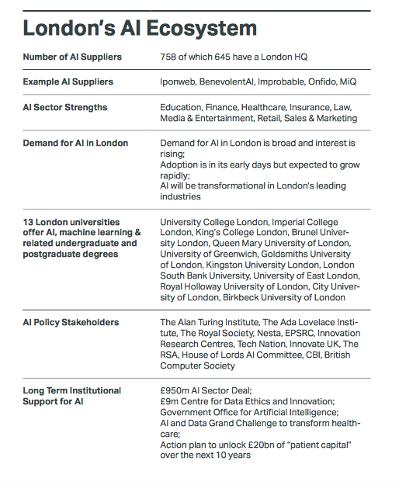
Figure 8: CognitionX. (2018). London: The AI Growth Capital of Europe. Retrieved from https://www.london.gov.uk/sites/default/files/london_theaigrowthcapitalofeurope.pdf

Germany

In the last 30 years, the German government has provided only €500 million in state aid for AI-related research. At the same time, the government realized the feed for increasing AI investments. Germany, in particular its capital, Berlin, will receive a big financial boost towards AI development as part of an effort for the European nation to compete with the US, Canada and China. Angela Merkel’s cabinet approved €3 billion worth of funding, which is expected to be matched by the private sector to bring the total investment up towards €6 billion.

European AI is also heavily supported by the European Commission, which plans to invest at least €20 billion by the end of 2020 in the AI sector.

Private actors are also heavily investing in German AI. For example, online retailing giant Amazon has partnered with Germany’s Max Planck Institute for Intelligent Systems, a leading AI research centre in Germany. According to details obtained by Handelsblatt, Amazon is investing nearly €2 million ($2.35 million) into the institute's work on artificial intelligence and robotics. But the Seattle-based company is going a step further: It plans to build its own research outfit in the southwest German city of Tübingen, where it will directly employ 100 scientists.

China

China is investing more than €50 billion in AI research by 2025 to build a business and research park that will attract companies from all around the world. It has publicly announced its intention to be world leader for AI by 2030. Beijing is getting a $2.1-billion technology park in Beijing entirely dedicated to the development of artificial intelligence. China has also been actively seeking partnerships with foreign research institutions and companies.

China also enjoys massive influx of investments from big tech giants, as well as international venture capitalists. It is second after the US in the total amount of AI funding.

US

The White House has made American leadership in AI a top priority. In a July 31, 2018, memo from the Executive Office of the President, leadership in AI (along with “quantum information sciences and strategic computing”) is named the second highest R&D priority after the security of the American people for the 2020 fiscal year. And on September 7, 2018, the US Department of Defense announced investments up to $2 billion over the next five years towards the advancement of AI. This is in addition to existing government spending on AI R&D, which totaled more than $2 billion in 2017 alone, just from unclassified programs and not including Pentagon and intelligence budgets. Existing funding has already propelled more than 20 active programs under the Defense Advanced Research Projects Agency (DARPA) exploring different aspects and uses of AI, and dozens of new projects have now been promised. Steven Walker, director of DARPA, has said the agency wants to uncover “how machines can acquire human-like communication and reasoning capabilities.”

In addition to public finances, the US enjoys a huge amount of private funding available for the development of AI both in terms of FDI (foreign direct investment) as well as portfolio investment. As one of the recent examples of massive investment, Toyota engaged in a 5-year, $1-billion research and development effort headquartered in Silicon Valley. As planned, the compound will be one of the largest research laboratories in Silicon Valley. Local-global tech giants such as Google and Facebook also give huge amount of funding to local universities and finance various entrepreneurship initiatives.

Conclusion

Patricia believes she provided a lot of useful information in her report about the investment situation in Montreal and compared it with other important AI hubs. She also created a section in the report where she synthesized information and outlined the major trends across hubs. This allowed her to develop ideas on how the Montreal AI hub could further develop a viable and sustainable model of financing its growing and dynamic AI community. She decided to share some of her ideas and insights during the upcoming presentation!

Task

Evaluate the current financial situation in the Montreal AI sector and help Patricia to develop a creative and comprehensive strategy of how Montreal could attract more investments in its AI sector.
References
Boix, R., Galletto, V. (2009). Innovation and Industrial Districts: A First Approach to the Measurement and Determinants of the I-District Effect. Regional Studies, 43 (9), 1117-1133.

Brewer, T., Guisinger, S., Young, S. (2003). The New Economic Analysis of Multinationals: An Agenda for Management, Policy and Research (New Horizons in International Business Series), Edward Elgar Publishing.

Keeble, D., Wilkinson, F. (1999). Collective Learning and Knowledge Development in the Evolution of Regional Clusters of High Technology SMEs in Europe. Regional Studies, 33(4), 295-304.

Laperche, B., Sommers, P., Uzunidis, D. (eds.) (2010). Innovation Networks and Clusters: the Knowledge Backbone, Peter Lang, Brussels.

Porter, M. (1998). Clusters and the new economics of competition. Harvard Business Review, 76(6), 77–90.

SAS Analytics. 2018. “Artificial Intelligence: What it is and why it matters”
[online]URL:https://www.sas.com/en_id/insights/analytics/what-is-artificial-intelligence.html

Turkina, E.,Van Assche, A., Kali,R. (2016). Structure and evolution of global cluster networks: evidence from the aerospace industry », Journal of Economic Geography, vol. 16, no 6, 2016, p. 1211-1234.

Turkina, E.,Van Assche. A. (2018). Global connectedness and local innovation in industrial clusters. Journal of International Business Studies, 49: 706.

Turkina, E.,Van Assche, A., Doloreux, D. (2019). A Tangled Tale of Cluster Co-Location in Greater Montréal, working paper.

Link to Montreal International : http://www.montrealinternational.com/en/ Link to Investissement Quebec: https://www.investquebec.com/international/en
https://www.investquebec.com/international/en/secteurs-activite-economique/technologies-information-communications/Montreal-s-Artificial-Intelligence-Hub.html
https://www.investquebec.com/international/en/secteurs-activite-economique/technologies-information-communications/Montreal-s-Artificial-Intelligence-Hub.html
Easton, L. (2018). Canada’s Artificial Intelligence Ecosystem — Montreal. Retrieved from https://medium.com/believing/canadas-artificial-intelligence-ecosystem-4798b0517016
https://www.montrealinternational.com/en/keysectors/artificial-intelligence/
Financial Post. (2018). DiDi Launches Labs in Toronto, Expanding Global Research Network to Canada. Retrieved from https://business.financialpost.com/pmn/press-releases-pmn/business-wire-news-releases-pmn/didi-launches-labs-in-toronto-expanding-global-research-network-to-canada
https://scaleai.ca/about-2/
CIFAR. (2018). Pan-Canadian Artificial Intelligence Strategy. Retrieved from https://www.cifar.ca/ai/pan-canadian-artificial-intelligence-strategy
https://www.investquebec.com/international/en/secteurs-activite-economique/technologies-information-communications/Montreal-s-Artificial-Intelligence-Hub.html
http://www.montrealintechnology.com/montreal-headquartered-scale-ai-selected-by-canadian-government-to-receive-part-of-the-950-million-supercluster-initiative/
http://www.montrealintechnology.com/montreal-universities-get-213-million-ai-big-data/
SCALE AI. (2018). CISION: $290 million in support for SCALE AI, the AI-powered Supply Chains Supercluster. Retrieved from https://www.newswire.ca/news-releases/290-million-in-support-for-scale-ai-the-ai-powered-supply-chains-supercluster-702086202.html
https://www.investquebec.com/international/en/secteurs-activite-economique/technologies-information-communications/Montreal-s-Artificial-Intelligence-Hub.html
http://www.canada.ai/posts/canadas-artificial-intelligence-ecosystem-montreal
https://betakit.com/city-of-montreal-announces-100-million-fund-for-smart-city-startups/
http://www.cbc.ca/news/canada/montreal/montreal-to-invest-360m-over-next-4-years-to-boost-economic-development-1.4627060
http://www.investquebec.com/international/en/press-room/news/Investissement-Quebec-scopes-Indian-direct-investments.html
Information taken from https://www.montrealinternational.com/en/invest/why-choose-montreal/
https://www.cbc.ca/news/technology/montreal-element-ai-102-million-funding-yoshua-bengio-1.4159602
"Angel investors: How to find them". www.bdc.ca. BDC/NACO
Gagné, Jf. (2018). Canadian AI Ecosystem. Retrieved from http://www.jfgagne.ai/blog/the-canadian-ai-ecosystem-in-2018
Gagné, Jf. (2018). Canadian AI Ecosystem. Retrieved from http://www.jfgagne.ai/blog/the-canadian-ai-ecosystem-in-2018
JF Gagné, also Galang, J. (2018). AI AND FINTECH : What’s next for canada’s hottest sectors? Retrieved from https://betakit.com/ai-and-fintech-whats-next-for-canadas-hottest-sectors/
JF Gagné , also Galang, J. (2018). AI AND FINTECH : What’s next for canada’s hottest sectors? Retrieved from https://betakit.com/ai-and-fintech-whats-next-for-canadas-hottest-sectors/
ibid
ibid
Gagné, Jf. (2018). Canadian AI Ecosystem. Retrieved from http://www.jfgagne.ai/blog/the-canadian-ai-ecosystem-in-2018
Invest in Canada. (n.d) Canada: A leader in artificial intelligence (AI). Retrieved from https://www.international.gc.ca/investors-investisseurs/assets/pdfs/download/Niche_Sector-AI.pdf
Toronto Global. (n.d.) Toronto is the answer for AI. Retrieved from https://torontoglobal.ca/ai
Toronto Global. (n.d.) Toronto is the answer for AI. Retrieved from https://torontoglobal.ca/ai
Information taken from this source : CognitionX. (2018). London: The AI Growth Capital of Europe. Retrieved rom https://www.london.gov.uk/sites/default/files/london_theaigrowthcapitalofeurope.pdf
https://www.telegraph.co.uk/technology/2018/11/28/uk-government-earmarks-3m-funding-ai-research-legal-financial/
https://www.gov.uk/government/collections/industrial-strategy-challenge-fund-joint-research-and-innovation
Chowdhury, H. (2018). Government earmarks £3m in funding for AI research for legal and financial services. Retrieved from https://www.telegraph.co.uk/technology/2018/11/28/uk-government-earmarks-3m-funding-ai-research-legal-financial/
Taylor, C. (2018). London is fast becoming a major hub for A.I. development. Retrieved from https://www.cnbc.com/2018/11/15/london-is-fast-becoming-a-major-hub-for-ai-development.html
CognitionX. (2018). London: The AI Growth Capital of Europe. Retrieved from https://www.london.gov.uk/sites/default/files/london_theaigrowthcapitalofeurope.pdf
Ibid
https://benevolent.ai/news/announcements/benevolentai-raises-115m-for-ai-enabled-drug-development
CognitionX. (2018). London: The AI Growth Capital of Europe. Retrieved from https://www.london.gov.uk/sites/default/files/london_theaigrowthcapitalofeurope.pdf
Ibid
Ibid
Ibid
Ibid
Ibid
Delhaes, D. (2018). Machine Learning: Grand plan for Franco-German AI research taking shape. Retrieved from https://www.handelsblatt.com/today/politics/machine-learning-grand-plan-for-franco-german-ai-research-taking-shape/23582366.html
Miley, J. (2018).Germany Boosts AI Research with €3bn Funding Injection. Retrieved from https://interestingengineering.com/germany-boosts-ai-research-with-3bn-funding-injection
http://europa.eu/rapid/press-release_IP-18-6689_en.htm
https://www.handelsblatt.com/today/companies/cyber-innovation-amazon-deepens-ties-with-german-ai-hub/23572706.html?ticket=ST-642083-D7e2QcvQ44KdSji0QNOP-ap5
Gillmann, B. (2017). CYBER Innovation: Amazon Deepens Ties With German AI Hub. Retrieved from https://www.handelsblatt.com/today/companies/cyber-innovation-amazon-deepens-ties-with-german-ai-hub/23572706.html?ticket=ST-116038-CzLd9nWb0QtMbF0KVdYx-ap3
Delhaes, D. (2018). Machine Learning: Grand plan for Franco-German AI research taking shape. Retrieved from https://www.handelsblatt.com/today/politics/machine-learning-grand-plan-for-franco-german-ai-research-taking-shape/23582366.html
Zhang, B. (2018) Beijing Is Getting a $2.1 Billion AI District. Retrieved from https://www.technologyreview.com/the-download/609892/beijing-is-getting-a-21-billion-ai-district/
FLI - Future of Life Institute. (2018). AI POLICY – UNITED STATES. Retrieved from https://futureoflife.org/ai-policy-united-states/?cn-reloaded=1#top
https://www.washingtonpost.com/technology/2018/09/07/defense-department-pledges-billions-toward-artificial-intelligence-research/?utm_term=.a8c5248832ad
https://futureoflife.org/ai-policy-united-states/
Information in this abstract is taken from FLI - Future of Life Institute. (2018). AI POLICY – UNITED STATES. Retrieved from https://futureoflife.org/ai-policy-united-states/?cn-reloaded=1#top
Markoff, J. (2015). Toyota Invests $1 Billion in Artificial Intelligence in U.S. Retrieved from https://www.nytimes.com/2015/11/06/technology/toyota-silicon-valley-artificial-intelligence-research-center.html

