Montreal’s artificial intelligence (AI) cluster:
How to keep talent in the city and attract global brains?

Introduction

It was a sunny and cheerful morning, unusually warm for early spring in Montreal. Boris enjoyed his walk to work: he parked his car a bit further away than usual and took time to enjoy the fresh air and observe busy people rushing off to work along the colourful streets of Montreal. He also needed this moment to reflect about the recruitment strategy for Element AI, Montreal-headquartered firm and a global leader in the artificial intelligence (AI) segment, where he was an applied research scientist.

Photo: Boris Oreshkin, Element AI

Element AI experienced a rapid expansion phase internationalizing to other global AI hubs while simultaneously continuing to hire aggressively in Montreal. At the same time, other tech giants including Google and Facebook had moved to Montreal in recent years and set up their own AI research labs. In parallel to these activities, a lot of local companies had emerged in these fields and were also looking for top talent.

Montreal has always been a leader in education in different subfields of AI, boasting, among other things, the highest number of graduates in deep learning (a critical subset of AI) than any other competing AI hub. At the same time, the exponentially growing need for AI talent has created a certain shortage of talent. Another important challenge is that even though there are amazing employment opportunities now in Montreal in the AI sector, many talented graduates leave to other hubs like Silicon Valley where the salaries are higher. At the same time, many top global AI researchers have connections with Montreal: they have engaged with academic programs in the city and some, including Hugo Larochelle, who is currently the head of Google Brain in Montreal, have left and then returned to Montreal to grow privately-funded AI labs. Nevertheless, with corporations anxiously recruiting the less than 22,000 people in the world who have the skills and knowledge to tackle tough AI problems—often through astronomic salaries—there is now an even greater need for top researchers to train the next generation talent. Boris has always actively participated in the recruitment of scientists for Element AI and he and his team started to see these important challenges relating to human resources. Boris and his colleagues felt like not only Element AI, but also the whole Montreal AI community needed to come up with a strategy to cultivate yet more talent, to keep the existing talent in the city, as well as to attract global AI talent.

Montreal’s artificial intelligence cluster

The artificial intelligence industry is projected to be worth $36 billion by 2025, and Montreal is right in the middle of these developments. At present, in addition to Element AI, Montreal boasts over 250 local AI firms as well as global technological giants such as Google, Facebook, Microsoft, Thales, and IBM.

An important factor that contributed to Montreal’s emergence as world-class AI cluster is the availability of a highly educated workforce. With its world-class universities and particularly advanced programs in computer and electrical engineering, operations research and decision sciences, every year Montreal has a very high number of tech graduates. For instance, Montreal boasts more than 250 researchers in deep learning at Montreal’s universities—the “biggest concentration in the world.” This concentration of expertise helps reinforce developments in AI applications and grow new AI-focused businesses. Montreal has four major public universities on the island alone (Concordia, McGill, University of Montreal, University of Quebec in Montreal), which all have advanced programs in fields critical for AI: deep learning, computer science, operation research, decision sciences. The city also has an impressive number of private and public academic institutions in the greater Montreal region. Montreal is also home to the Institute for Data Valorization (IVADO), which is responsible for research in AI and Big Data and was itself the recipient of $93.5 million from the First Research fund in 2016.

Montreal professor Yoshua Bengio is considered one of the three fathers—along with Geoffrey Hinton (Toronto) and his student Yann LeCun (educated in Toronto, now working in NYC)—of deep learning. In 2019, all these three scholars received a Turing prize, which is the equivalent of Nobel prize in computer science; some call this the victory of Canadian AI education. Yoshua Bengio earned three degrees at McGill University, Montreal, including a PhD in computer science. He has been a professor and researcher at the University of Montreal since 1993, where he has established the world-famous Montreal Institute for Learning Algorithms (MILA), which has attracted a lot of government funds, as well as private investments. He also co-founded Element AI. Yoshua Bengio’s popularity and importance grew between 2010–2012, a time marked by the rise of big data and the massive growth of available computing power: suddenly the fundamental algorithms he had been working on for more than 20 years became applicable to industry and businesses.

While some countries (e.g. the US) continue to close borders and deny visas to top researchers from other countries, Canada has made significant efforts to make AI more inclusive. For instance, an initiative at MILA aims to bring promising research students from developing countries for 3-6 month internships to work with some of the top researchers in AI.

The province of Quebec also has some of the lowest tuition in North America, as well as some of the lowest rents in Canada due to rent control. Additionally, the city has a large and very vibrant cultural scene and a legacy of creativity. Montreal has been constantly named the top city in the world for students due to its affordability, desirability and rich culture.
Additionally, technology businesses in Quebec benefit from a variety of extremely generous tax credits and grants, which helps explain why so many technology companies start or move here and why so many foreign investors are now speculating here. In 2015, Quebec’s tech sector accounted for 6.4 percent of jobs in the province—the highest rate in all of Canada (California’s rate, by comparison, is 8.2 percent).

In the past three years, there has also been a major influx of privately-funded AI research labs to Montreal, driven by the convergence of talent and proximity to key resources for information exchange and collaboration.

Here is the timeline with the most notable developments:

- Element AI, co-founded in 2016 by Yoshua Bengio and a team of experienced tech entrepreneurs including Jean-Francois Gagne (current CEO). The team has quickly expanded to 500 employees over the past two years and the firm became the largest privately-owned AI R&D lab.
- Microsoft acquired Montreal AI lab Maluuba in early 2017 and doubled technical experts over the next two years.
- Samsung Electronics’ Advanced Institute of Technology (SAIT) opened an AI lab in the University of Montreal in August 2017. SAIT has been collaborating with Bengio and other partners from the University of Toronto, McGill University and NYU since 2014.
- Google Brain recruited a former student of Bengio and Montreal native, Hugo Larochelle, in mid-2017, to run their AI research in Montreal.
- Facebook established a research lab in Montreal in late 2017 and hired Joelle Pineau (a McGill University Professor of Computer Science) to head this lab. The lab hired 10 researchers initially and tripled in size by the end of 2018.
- DeepMind, acquired by Google in 2014, opened an AI research lab in October 2017 headed by Doina Precup (McGill University Professor of Computer Science).
- Thales SA opened an AI lab in Montreal in collaboration with MILA. They plan to hire 50 AI scientists by mid-2019.
- The Royal Bank of Canada opens the Borealis AI lab in 2018. They hired 10 researchers on staff in the first year and plan to rapidly expand.
- In 2019 over thirty new AI start-ups opened in Montreal and Scale AI consortium received federal funding as one of the selected projects for supercluster initiative. Scale AI, a business-led consortium, is dedicated to building the next-generation supply chain and boosting industry performance by leveraging AI technologies. It is supposed to drive economic growth, bolster Canada’s leadership in the global innovation race, create highly-skilled jobs, and accelerate the adoption of AI-powered technologies.
- Montreal benefited significantly from the Government of Canada’s $125-million Pan-Canadian Artificial Intelligence Strategy administered by the Canadian Institute for Advanced Research (CFAR), which in turn works in partnership with three AI institutes—the Alberta Machine Intelligence Institute (Amii) in Edmonton, MILA in Montreal and the Vector Institute in Toronto. The Strategy has four major goals:

- To increase the number of outstanding artificial intelligence researchers and skilled graduates in Canada.
- To establish interconnected nodes of scientific excellence in Canada’s three major centres for artificial intelligence (Edmonton, Montreal and Toronto).
- To develop global thought leadership on the economic, ethical, policy and legal implications of advances in artificial intelligence.
- To support a national research community on artificial intelligence.

Figure 1 below shows the dynamism and vibrancy of Canadian AI. While Toronto is the largest hub in the world in terms of start-ups, Montreal is leading in research.

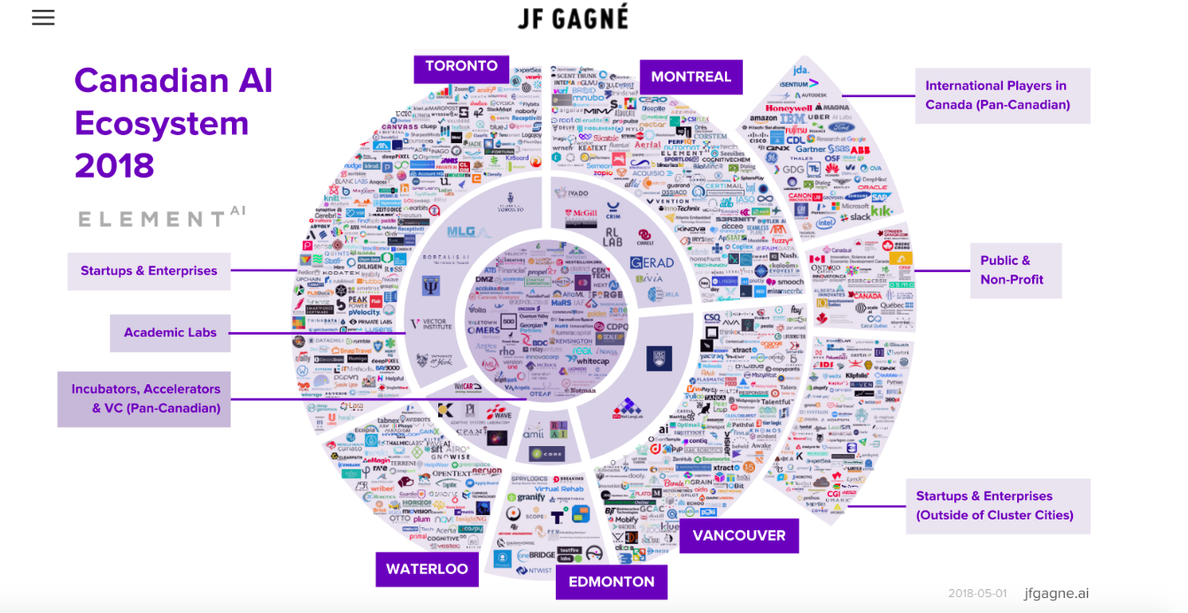

Figure 1: Gagné, Jf. (2018). Canadian AI Ecosystem. Retrieved from http://www.jfgagne.ai/blog/the-canadian-ai-ecosystem-in-2018

In recent years, Canada has become a fast-growing, global tech and innovation center. A record CAD $ 447 million of venture capital has been injected into Canadian AI startups between 2015 and 2017, with the country’s AI talent pool ranking third in the world, behind the US and the UK only. Figure 2 below demonstrates the advantages of Canadian AI.

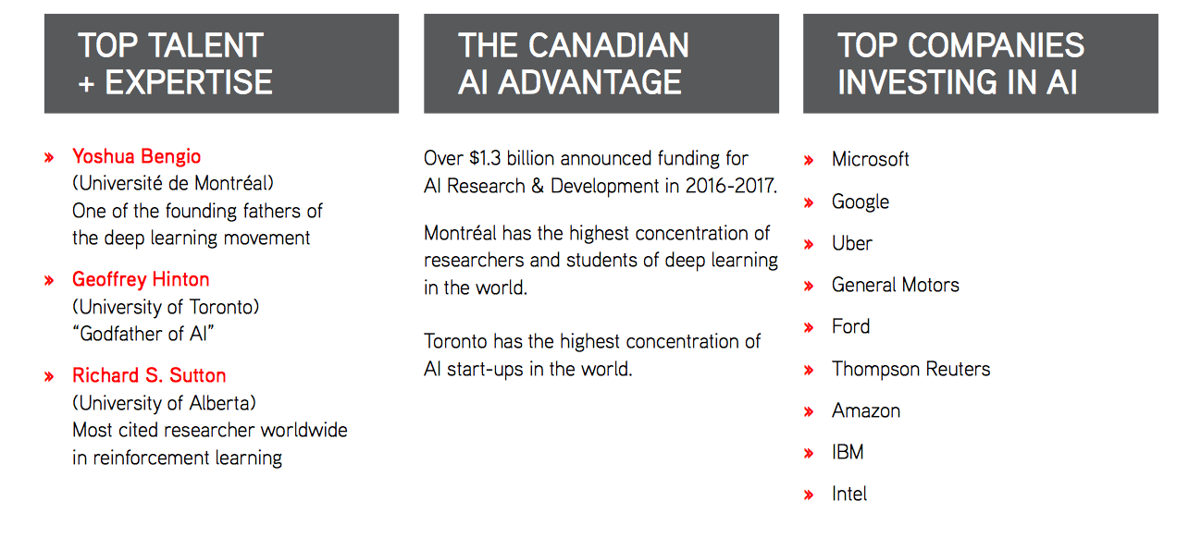
Figure 2: Invest in Canada. (n.d) Canada: A leader in artificial intelligence (AI). Retrieved from https://www.international.gc.ca/investors-investisseurs/assets/pdfs/download/Niche_Sector-AI.pdf

At the same time, fewer artificial intelligence patents have been filed in Canada since 2016, despite massive government investments and the creation of many new AI companies since January 2016. Over the past decade, Canada had the fifth most patents globally that included the words “artificial intelligence,” based on an analysis by The Logic of data from the World Intellectual Property Organization (WIPO). That rank is at risk of falling. Canada is the only jurisdiction among the top 10 AI patents filed to see a decrease in the number of patents applied for every year between 2016 and 2018. Therefore, it is highly critical for Montreal AI hub to develop appropriate human resource strategy in order to retain talent and attract global talent capable of publishing patents.

As far as patent production is concerned, the US and China are top leading patent publishers in the AI industry (Figure 3).
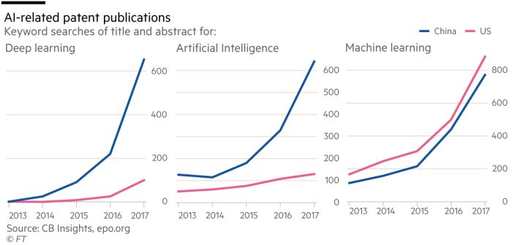

Figure 3: AI patents, China vs. US

Other tech clusters in Montreal

Researchers argue that co-location (regional agglomeration) and effective interaction among firms, research institutions and universities in a particular sector enables the exploitation of “locational economies” or “agglomeration economies,” benefits that arise from the co-location of related economic activities. This phenomenon is also called clustering. It has been argued that clusters have strong effects on firm innovation since firms located in clusters benefit from information exchange and collaboration on concrete projects, as well as from availability of skills and talent in regional agglomerations (Porter, 1998; Keeble and Wilkinson, 1999). Researchers speak about the emergence of learning clusters, or regional innovation hubs, where firms, universities, regional authorities and for-profit and not-for-profit research institutions collaborate together and share resources and knowledge on specific projects (Asheim, 2001; Porter, 1990, 1998, 2003). Clusters further the international outreach of a region by attracting foreign investment and highly skilled workers. They stimulate entrepreneurship. “They improve the capacity to innovate and productivity by easing the interactions and complementarities that exist between their firms. They foster social capital.” (MontrealClusters, 2018). Additionally, it has been argued (Turkina, 2019) that it is beneficial for a region to have advanced clusters in several industries, because this increases significantly the pool of talent and creates positive spillovers for each of the co-located clusters.

In addition to the emerging artificial intelligence cluster, Montreal boasts several mature high-tech clusters. The major ones are:

- Information, Communication and Technology (ICT) cluster (TehcnoMontreal) with over 5000 ICT companies and more than 14 000 university students enrolled in fields related to ICT.
- Aerospace cluster (Aero Montreal) with over 400 aerospace companies, making it the third biggest aerospace cluster in the world after Seattle and Toulouse;
- Écotech, world’s leading cluster in clean technologies that comprises over 1000 different firms and organizations with more than 1 B$ in total revenues and annual investments in R&D of nearly 300M$ (Ernest & Young, 2018), etc.

Each of these mature tech clusters “benefits from the support of a secretariat (or in other words, cluster association) financed by the private sector, the Montreal Metropolitan Community and the Quebec government. Cluster secretariats include firms, business associations, Emploi-Québec's sectoral workforce committees, the Quebec and Canada governments and research and training institutions. The secretariats bring together key industry players designated by the community” (MontrealClusters, 2018).

Major AI hubs across the globe in terms of trends, jobs, salaries
and pools of talent

Last week Boris and his team examined the other major AI hubs across the globe with regard to their pools of talent, salaries and education-research initiatives. While enjoying his walk to work, Boris reflected on this report and developed some interested ideas to share with his colleagues.

Figure 4 below presents some statistics on the jobs in the artificial intelligence industry and salaries. The upper part of the figure contains the graphs related to the US statistics. The lower graphs present world-level statistics.
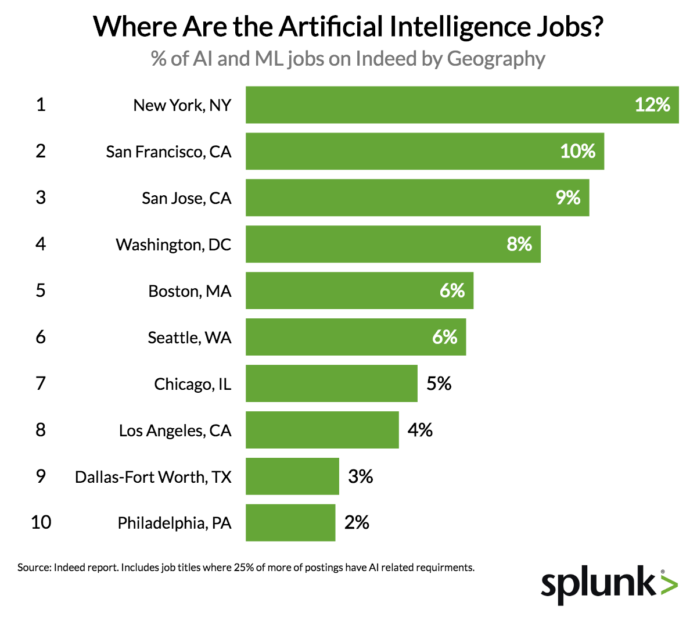 | 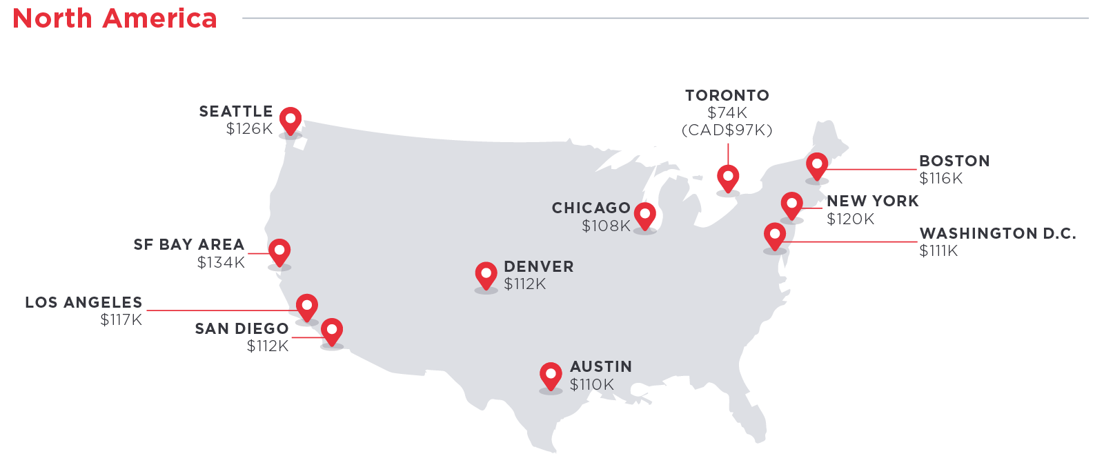
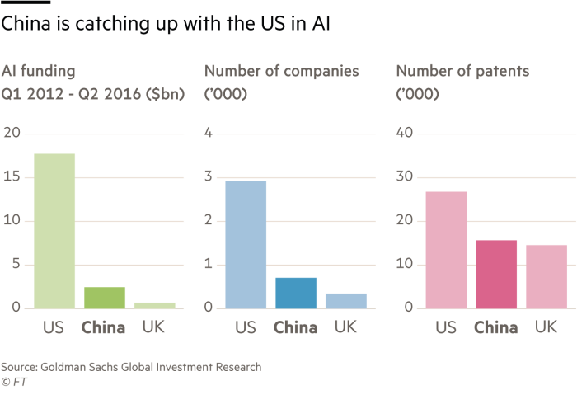 | 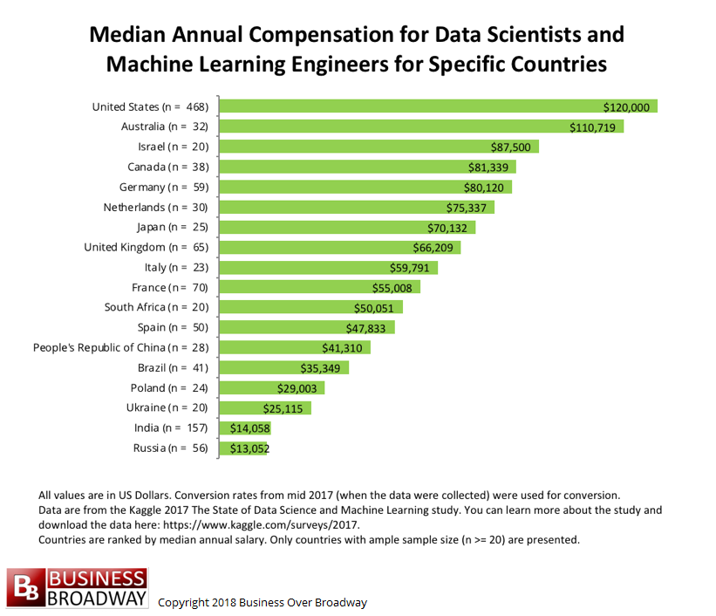

Figure 4: Statistics on the availability of jobs in AI and salaries; AI funding and patents

The US is still a top destination for AI scientists in terms of monetary compensation, as well as availability of jobs. Silicon Valley offers the highest salaries in the world. However, New York boasts the highest percentage of AI and machine learning positions in a single metro area, with more than 11% of national job postings (Figure 4).

At the same time, as far as new job creation is concerned, Canadian hubs exhibit higher new job creation growth. For instance, in the past year there were more new tech jobs added in the Toronto Region than New York City and the San Francisco Bay Area combined. In terms of job numbers, the Toronto Region has surpassed such important hubs as Boston, Chicago and Seattle. However, as shown in Figure 4, Toronto salaries are still not as competitive as US salaries. Montreal and Toronto salaries are similar in tech industries. Montreal also shows high growth of AI job creation, but it is behind Toronto in this dimension.

In addition, Canada has been very entrepreneurial in launching different initiatives providing coaching to firms and entrepreneurs to boost the growth of local start-ups, and at the same time, to attract foreign talent to Canada. For instance, in Montreal, Element AI has its own coaching program for start-ups. Montreal-Toronto collaborate in the Next AI initiative, which is a global innovation hub for AI-related venture creation and technology commercialization. It identifies talented teams and individuals with ambitious ideas and leverages Canada’s leadership position in AI to provide them with the capital, mentorship, education and network to disrupt industries. NextAI teams have access to up to $200,000 in capital, world-renowned faculty and scientists, a network of Canada’s top business leaders and entrepreneurs, and access to cutting edge AI tools In Montreal and Toronto. Canada also benefits from the current US administration’s harsh immigration policies and quite a number of talented Middle-Eastern, Asian and East European students, researchers and professionals choose Canada for jobs and permanent residency.

Global trends indicate that the US, China and the UK are leading in total numbers in terms of the availability of AI funding, number of companies and number of patents. China grew massively in AI technologies and is trying to position itself as world’s leading AI power.

A “key difference in China is there are just more people, more data, more businesses — it’s just bigger,” says chief technology officer Matt Scott, a former Microsoft researcher who moved to China to co-found the company. “Having access to that data in China, we can export [the technology] around the world.”

As far as the supply side is concerned, World Economic Forum, the international organization, used LinkedIn data to find that the size of Canada’s AI workforce is lagging behind the US, India, Germany and Switzerland, but beating dozens of countries including France, Spain, Singapore and Sweden (Figure 5). At the same time, Canada has the third largest concentration of AI researchers in the world. The US has the highest concentration of researchers at 9,010 researchers, followed by the UK with 1,861; Canada took third place with 1,154 researchers.
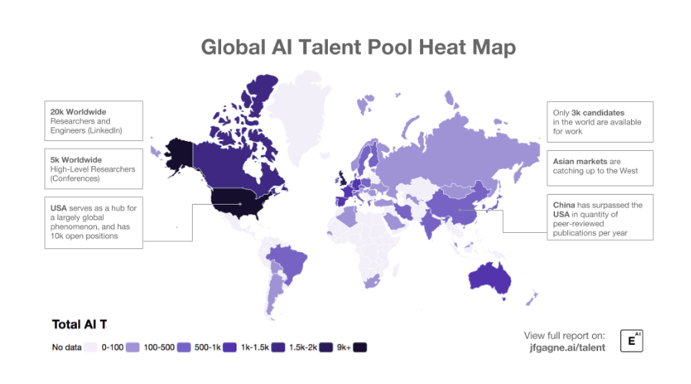
Figure 5: Mason, Q. (2018). Montreal in technology: Canada has third largest concentration of AI researchers in the world, according to Element AI report. Retrieved from http://www.montrealintechnology.com/canada-has-third-largest-concentration-of-ai-researchers-in-the-world-according-to-element-ai-report/
At the same time, the Forum found as part of its annual rankings on gender disparities that women only make up 24 per cent of Canada’s AI workforce, and 22 per cent of the world’s AI workforce.

The Forum indicated that the lack of women in Canada’s and the global AI pool is troubling because it implies that technology is being developed without diverse talent, thus “limiting its innovation and inclusive capacity.” Low integration of women in AI talent pools is a “significant missed opportunity in a professional domain where there is already insufficient supply of adequately qualified labour.”

If not addressed soon, the Forum warned that the gap could widen further. Sarah Kaplan, the director of the University of Toronto’s Institute for Gender and the Economy, argued that Canada needs to do more to develop the diversity of the AI workforce because the technology has the potential to replace lots of human processes and decisions:

“If we don’t have a diverse workforce working in AI, we risk not only perpetuating existing biases, but actually amplifying them and leading to really negative outcomes for the most vulnerable people in our society”

Out of all the Canadian AI hubs (Montreal, Toronto, Edmonton and Vancouver), the situation with female workers is the best in Vancouver. Vancouver’s rapidly developing AI industry has attracted a lot of female engineers and company leaders. The city’s chapter of Women Who Code, a global non-profit organization supporting women in technology, has over 1 600 members.

The next sections give a detailed information on the AI research institutions and opportunities existing in major AI hubs.

Research institutions and opportunities in major AI hubs competing with Montreal

Since AI is a very research-intense industry, talented specialists are attracted not only by jobs and existing opportunities in the industry, but also by research opportunities. All the firms in the AI industry are trying to not only produce patents, but also largely focus on publications that advance Al knowledge and add prestige and status to corporations. A lot of research is done in cooperation with the universities and various research institutions.

Toronto’s major research institutions

Vector Institute

The new Vector Institute is an independent, non-profit research institution dedicated to the transformative field of artificial intelligence, excelling in deep learning and machine learning. Notable corporate partners are Google, Shopify, Loblaws, Accenture, Thomson Reuters, Magna International, NVIDIA, Uber, Air Canada, and all five major Canadian banks.

University of Toronto (U of T)

University of Toronto ranks among the top computer science departments worldwide. Computer Science at U of T is known for its work in neural networks, computer graphics, machine learning, theory, human-computer interaction (HCI), scientific computation, computer performance evaluation, robotics, computer vision, to computer animation, bioinformatics, and more. The university’s research is supported by the Natural Sciences and Engineering Research Council (NSERC), the Institute for Robotics and Intelligent Systems (IRIS), Communications and Information Technology Ontario (CITO) and Bell University Laboratories (BUL), and additional federal and provincial governments’ sources and corporations.

Research opportunities in London

According to the recruitment website Indeed, London offered 868 AI jobs per million jobs in the city in 2018, among the top in Europe:

“London doesn’t have the ecosystem to manage and scale companies like Silicon Valley does… But London is ahead in the quality of scientists and engineers.”

Figure 6 below indicates that the major attractivity of London AI hub is indeed its pool of talent. “It is very challenging for large tech companies to attract and retain talent in this sector, and London has a lot of AI talent that is pushing the boundaries of technology and its application.” Investors in the sector rated access to skills as their top priority when considering where to invest, according to CognitionX, with 62 percent naming London as the best European location for AI talent. With 13 universities offering AI-related degrees, London is seen as an important hub for growing talent as well as attracting it.

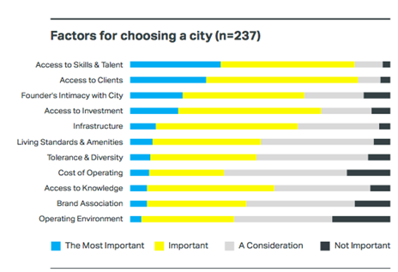
Figure 6: London attractivity

It has been estimated that AI could add £630bn to the UK economy by 2035. The UK boasts a number of the best world’s research institutions, such as Cambridge, Oxford and Imperial College (with all three having very strong programs in computer science and other AI-related fields), Digital Catapult, DigitalHealth.London, Founders Factory, Google Campus London, Innovate Finance, Level39, MedCity, Moving Brands, Tech.London, Tech London Advocates, Tech Nation, Techstars, TechUK, The Alan Turing Institute, UK Business Angels, University College London, Wideacademy.

One of the major institutions focusing on AI research is The Alan Turing Institute. Headquartered in the British Library, London, it was created as the national institute for data science in 2015. In 2017, as a result of a government recommendation, it added the artificial intelligence discipline. The Institute is named in honour of Alan Turing (June 23, 1912 – June 7, 1954), whose pioneering work in theoretical and applied mathematics, engineering and computing is considered to be the key disciplines comprising the fields of data science and artificial intelligence.

Five founding universities—Cambridge, Edinburgh, Oxford, UCL and Warwick—and the UK Engineering and Physical Sciences Research Council created The Alan Turing Institute. Eight new universities—Leeds, Manchester, Newcastle, Queen Mary University of London, Birmingham, Exeter, Bristol, and Southampton—joined the Institute in 2018.

The Institute is helping to make the UK the best place in the world for data science and AI research, collaboration, and business.

US research institutions

New York-Boston area boasts a cluster of top-notch US east-coast academic institutions — MIT, Harvard, Boston University and Cornell — that all have well-developed cooperation with industry. The most active academic research group is the MIT Computer Science & Artificial Intelligence Lab (CSAIL). The New York - Boston area is also home to the famous MIT-IBM Watson AI lab.

As far as the west coast is concerned, Silicon Valley has a lower number of universities, but Stanford University is famous for computer science and research in AI. The Stanford Artificial Intelligence Laboratory offers various courses, hosts engaging events, and manages outreach programs to local schools. Courses include topics such as the Cutting Edge of Computer Vision, Decision Making Under Uncertainty, and Advanced Robotic Manipulation. At the same time, Silicon Valley is famous for different private education and research initiatives organized by tech giants such as Google and Facebook.

Emerging world: trends in research in India and China

China has demonstrated remarkable ambition to master and dominate artificial intelligence. It has publicly announced its intention to be world leader for AI by 2030. The central government published a three-year plan to invest huge sums in AI, and to apply the technology across the country’s industries and economy. The Chinese Ministry of Education developed an ambitious “AI Innovation Action Plan for Colleges and Universities,” which was issued to the education departments at all levels and institutions of higher education. The plan proposed the establishment of 50 AI faculties, research institutions, or interdisciplinary research centers. As part of the plan, China’s respected Peking University (that has already advanced programs in IT, computer science and engineering), is opening a new campus with a focus on artificial intelligence and engineering. The new campus is set to occupy an area of nearly 4.15 million square metres (approximately 128 football fields) and is located in Changping, a district situated in the suburbs of northwest Beijing. Moreover, Beijing is getting a $2.1 Billion technology park in Beijing entirely dedicated to the development of artificial intelligence. China has also been actively seeking partnerships with foreign research institutions and companies.

As far as India is concerned, it has been recognized as an emerging AI hub with big potential. The country has traditionally very strong education in mathematics, engineering, computer science, and its Bangalore ICT cluster and other tech hubs provide good basis for the growth of AI technologies. India has a number of performing research institutions, including India’s Center for Artificial Intelligence & Robotics (CAIR), operating under the country’s Defence Research and Development Organization (DRDO) that has been focusing on AI since 1986.

At the same time, India has recognized its weakness in terms of the lack of PhD-level research in AI compared to other global hubs:

“We’ve typically seen that at the moment there’s around 7 000-10 000 data scientists in India, and we noticed that (only) about 2% are PhDs,” says Rishabh Kaul, co-founder, Belong, a Bengaluru-based HR-tech startup.

Therefore, in recent years the country focused on creating a number of advanced PhD-level research programs, as well as various postgraduate programs in AI and machine learning.

Conclusion

Boris kept thinking about the upcoming shortages of talented workers and researchers given the exponential growth of the industry and fast development of different AI hubs across the globe. The more he thought about it, the more he was coming to a conclusion that it is not only Element AI that has to come up with an innovative recruitment strategy—the entire Montreal hub has to join forces in order to retain graduating talent and attracting global talent from other competing AI hubs.

Task

Help Boris and Montreal AI stakeholders come up with a viable long-term talent growth and retention solution, as well as global talent recruitment strategy. How could Montreal recruit talented workforce from other AI hubs?

References
Asheim, B.T (2001). Learning Regions as Development Coalitions: Partnership as Governance in European Workfare States? Concepts and Transformation. International Journal of Action Research and Organizational Renewal, 6, 73-101.

Deschamps, T. (2018). Canada has fifth biggest AI workforce, but still lacks diversity: study. Retrieved from https://business.financialpost.com/pmn/business-pmn/canada-ranks-16th-on-world-economic-forums-annual-gender-gap-list

Keeble, D., Wilkinson, F. (1999). Collective Learning and Knowledge Development in the Evolution of Regional Clusters of High Technology SMEs in Europe. Regional Studies, 33(4), 295-304.

Montreal Clusters. (2018). “Montreal’s Metropolitain Clusters.” Retrieved from: http://cmm.qc.ca/fr/a-propos/
Porter, M. (1998). Clusters and the new economics of competition. Harvard Business Review, 76(6), 77–90.

Porter, M.E. (1990, 1998). The Competitive Advantage of Nations. Free Press, New York, 1990.

Porter, M. E. (2003). The economic performance of regions, Regional Studies, 37, 549–578.

TechnoMontreal. (2017). “About us.” Techno Montréal. Retrieved from: http://www.technomontreal.com/en/technomontreal/about-us
Turkina, E.,Van Assche, A., Doloreux, D. (2019). A Tangled Tale of Cluster Co-Location in Greater Montréal, working paper.

https://www.nytimes.com/2017/10/22/technology/artificial-intelligence-experts-salaries.html
https://medium.com/believing/canadas-artificial-intelligence-ecosystem-4798b0517016
https://www.ibm.com/blogs/insights-on-business/ibmix/montreal-became-worlds-leading-ai-deep-learning-hub/
https://www.ibm.com/blogs/insights-on-business/ibmix/montreal-became-worlds-leading-ai-deep-learning-hub/
http://www.canada.ai/posts/canadas-artificial-intelligence-ecosystem-montreal
https://www.hec.ca/en/news/2016/IVADO-receives-93-6-M-grant-from-Canada-First.html
https://www.ibm.com/blogs/insights-on-business/ibmix/montreal-became-worlds-leading-ai-deep-learning-hub/
Ibid
Ibid
https://www.forbes.com/sites/williamfalcon/2018/12/03/cifar-this-is-how-canada-funds-its-ai-leadership/#21824165a03c
https://www.ibm.com/blogs/insights-on-business/ibmix/montreal-became-worlds-leading-ai-deep-learning-hub/
https://www.ibm.com/blogs/insights-on-business/ibmix/montreal-became-worlds-leading-ai-deep-learning-hub/
Ibid
Easton, L. (2018). Canada’s Artificial Intelligence Ecosystem — Montreal. Retrieved from https://medium.com/believing/canadas-artificial-intelligence-ecosystem-4798b0517016
https://scaleai.ca/wp-content/cache/page_enhanced/aisupplychain.ca/_index_ssl.html_gzip
CIFAR. (2018). Pan-Canadian Artificial Intelligence Strategy. Retrieved from https://www.cifar.ca/ai/pan-canadian-artificial-intelligence-strategy
https://www.blogto.com/tech/2018/11/chinas-uber-competitor-didi-chuxing-has-arrived-toronto/
Schwartz, Z. (2018). The Logic: Canada falling behind in global race for artificial intelligence patents. Retrieved from https://thelogic.co/news/exclusive/canada-falling-behind-in-global-race-for-artificial-intelligence-patents/
Schwartz, Z. (2018). The Logic: Canada falling behind in global race for artificial intelligence patents. Retrieved from https://thelogic.co/news/exclusive/canada-falling-behind-in-global-race-for-artificial-intelligence-patents/
https://papers.ssrn.com/sol3/papers.cfm?abstract_id=3100238
Écotech website : http://www.ecotechquebec.com/; Environment is one of the main concerns for the smart cities and you can find “For example, the EU’s smart city initiative is attempting to increase energy efficiency 20% by 2020 through smart energy grids and streetlights.” (BI Intelligence, 2016). Aeromontreal website : https://www.aeromontreal.ca/; “The Québec aerospace industry has four prime contractors and nearly 15 world-class OEM integrators that can rely on a vast network of subcontractors and suppliers of specialized products.” - “Recognized prime contractors: Bell Helicopter Textron Canada, Bombardier, CAE, Pratt&Whitney Canada, Esterline CMC Electronics, General Electric Canada – Aviation, Héroux-Devtek, L-3 MAS, Liebherr-Aerospace Canada, MDA Satellite Systems, Mecachrome Canada, Messier-Bugatti-Dowty, Rolls-Royce Canada, Sonaca Montréal & Turbomeca Canada.” Tehcno montreal website : http://www.technomontreal.com/en
For more information on Écotech see https://www.ecotechquebec.com/en/
LiveMint. (2018). Home AI: New York is the capital of a booming artificial intelligence industry. Retrieved from https://www.livemint.com/AI/9elTM0PCXCrA54WeLAWA9L/New-York-is-the-capital-of-a-booming-artificial-intelligence.html
https://torontoglobal.ca/ai
https://torontoglobal.ca/ai
The following websites presents more detailed information on tech salaries across Canadian cities: http://www.planetweb.ca/news/tech-salaries-in-toronto-montreal-vancouver-revealed-2018/
NextCanada. (n.d) Why NextAI?: What we do. Retrieved from http://www.nextcanada.com/next-ai
https://www.ft.com/content/e33a6994-447e-11e8-93cf-67ac3a6482fd
http://www.montrealintechnology.com/canada-has-third-largest-concentration-of-ai-researchers-in-the-world-according-to-element-ai-report/
Deschamps, T. (2018). Canada has fifth biggest AI workforce, but still lacks diversity: study. Retrieved from https://business.financialpost.com/pmn/business-pmn/canada-ranks-16th-on-world-economic-forums-annual-gender-gap-list
Ibid
Ibid
Ibid
Toronto Global. (n.d.) Toronto is the answer for AI. Retrieved from https://torontoglobal.ca/ai
Information taken from AI Directory. (n.d) University of Toronto: Computer Science Department. Retrieved from https://www.itworldcanada.com/ai/listing/university-of-toronto/
Taylor, C. (2018). London is fast becoming a major hub for A.I. development. Retrieved from https://www.cnbc.com/2018/11/15/london-is-fast-becoming-a-major-hub-for-ai-development.html
Ibid
Taylor, C. (2018). London is fast becoming a major hub for A.I. development. Retrieved from https://www.cnbc.com/2018/11/15/london-is-fast-becoming-a-major-hub-for-ai-development.html
Ibid
https://www.gov.uk/government/publications/growing-the-artificial-intelligence-industry-in-the-uk/executive-summary
Information in the abstract about the Alan Turing Institute was taken from: The Alan Turing Institute. (2019). About us. Retrieved from https://www.turing.ac.uk/about-us
Ibid
The Alan Turing Institute. (2019). About us. Retrieved from https://www.turing.ac.uk/about-us
Synced. (2917). 2017 in Review: 10 Leading AI Hubs. Retrieved from: https://medium.com/syncedreview/2017-in-review-10-leading-ai-hubs-e6f4d8a247ee
Synced. (2917). 2017 in Review: 10 Leading AI Hubs. Retrieved from: https://medium.com/syncedreview/2017-in-review-10-leading-ai-hubs-e6f4d8a247ee
https://successfulstudent.org/best-artificial-intelligence-colleges/
https://www.technologyreview.com/f/609892/beijing-is-getting-a-21-billion-ai-district/
https://syncedreview.com/2018/04/10/china-puts-education-focus-on-ai-plans-50-ai-research-centres-by-2020/
Sarazen, M. (2018) Peking University to Open New Campus With AI Focus. Retrieved from https://medium.com/syncedreview/peking-university-to-open-new-campus-with-ai-focus-5e0eadc1381
Zhang, B. (2018) Beijing Is Getting a $2.1 Billion AI District. Retrieved from https://www.technologyreview.com/the-download/609892/beijing-is-getting-a-21-billion-ai-district/
Synced. (2917). 2017 in Review: 10 Leading AI Hubs. Retrieved from: https://medium.com/syncedreview/2017-in-review-10-leading-ai-hubs-e6f4d8a247ee
https://www.analyticsindiamag.com/top-10-courses-and-training-programs-on-artificial-intelligence-in-india-ranking-2018/

