Montreal’s artificial intelligence (AI) hub:
Boosting international outreach, enhancing local firm internationalization and attracting international investments

Introduction

It was a rainy and gloomy morning in early April, and though it was quite warm outside, people in the busy downtown rushed to their workplaces to enjoy their morning cups of coffee inside. Since there were none of the usual line-ups in the coffee shops, Nicolas Frense decided to get a takeout coffee from a nice boutique coffee place. Montreal was famous for its coffee culture and Nicolas thought it was a good idea to benefit from the rainy weather.

Photo: Nicolas Fresne

Nicolas Fresne worked as Director of Strategies and International Affairs at Investissement Quebec, an organization that offers guidance and financial solutions to corporations that are looking to set up in Quebec, as well as assists local companies in internationalization abroad. It was established in 1998 under an Act passed by the National Assembly of Quebec to favour investment in Quebec by Quebec-based and international companies.

This morning, Nicolas had an important meeting with his colleagues to develop a strategy to increase the international exposure of Montreal’s AI hub by attracting more international investors and high-performance Canadian and foreign firms, and to assist local AI firms in exploring foreign markets. Recent years had been very good to Montreal, as the major leaders of the AI industry—including Google, Facebook, and Microsoft—all came to Montreal to open AI research labs, pouring and attracting millions and millions of investments into the city. Additionally, local start-up Element AI has quickly become a research leader in the field by becoming the largest private AI research lab in the world. Element AI rapidly internationalized abroad, opening offices in London, Tokyo, Singapore, as well as Toronto.

At the same time, Nicolas and his team understood that the AI industry was experiencing important growth worldwide. Different countries and regions were developing national AI strategies (including Canada), and it was very important to catch the momentum and develop an adequate strategy for Montreal in order to strengthen its status as a leading hub in this new dynamic industry and keep attracting innovative Canadian and foreign companies. Nicolas and his colleagues also realized another challenge: the majority of local firms and start-ups experienced difficulties in scaling-up, and it was very important to assist them in local growth and to help them successfully internationalize to potential markets. Realizing that multiple actors have to participate in the development of such a strategy, Nicolas and his team invited the representatives of several important players to the meeting scheduled this morning, including Ville de Montreal, Digital and Smart City Office; Montreal International; Element AI; IVADO (Institute for Data Valorization); Google AI lab, and University of Montreal’s MILA (Institute for Machine Learning Algorithms). Nicolas had asked his research assistants to prepare a report about local and international activities in the AI industry. Over the weekend, he read this report closely and generated some ideas for possible international strategy for Montreal’s dynamic and developing AI hub. Hehe could not wait to share his thoughts with his colleagues and partners.

Montreal’s AI hub: major developments

According to the report, the main strengths of the Montreal AI hub are based on the configuration of talent and historical strength in adjacent fields important for AI technologies, such as operations research, mathematics and algorithm development, electrical and computer engineering, biomedical engineering, and fintech. Montreal has world-renowned universities offering top programs globally in these fields, such as the Montreal Institute for Learning Algorithms (MILA), which is operated out of University of Montreal and headed by Yoshua Bengio, one of the gurus of AI; and McGill University’s Engineering and Computer Science department (where Yoshua Bengio and other leaders in the field got their degrees). Together with Geoffrey Hinton (Toronto) and his student Yann LeCun (educated in Toronto , now working in NYC), Yoshua Bengio is considered one of the three fathers of deep learning, a critical subset of AI. In 2019, these three scholars received a Turing prize, which is the equivalent of Nobel prize in computer science; some proclaimed this as the victory of Canadian AI education.

Additionally, the city has been very strong in applied biomedical and fintech sciences with leading hospitals (e.g. Montreal Neurological Institute) and data science labs set up by different banks. Moreover, Montreal has had flourishing high-tech industries: for instance, its Techno ICT cluster comprises over 5000 firms and relevant organizations and is consistently ranked 3rd in North America for job growth in the ICT sector. The videogaming subsector of this cluster, led by Ubisoft and other digital art companies, is among the world’s best. Aéromontreal is the world’s third leading aerospace cluster after Toulouse and Seattle, with around 400 high-performance firms. Montreal also has a very advanced Ecotech cluster (green industry) represented by over 1000 cleantech organizations. The city has also been famous for its design and fashion cluster, as well as creative industries using digital techniques. Recently, when the computational power and availability of big data caught up with the fundamental research in AI, different industries realized the big commercial potential of AI models developed by fundamental scientists. As a consequence, Montreal has become a global hotspot in the new emerging AI industry as all the ingredients were in place to foster these developments.

First, as mentioned above, Montreal boasts an impressive pool of talent: every year, the city has a very high number of tech graduates. McGill University and University of Montreal alone have more than 250 researchers and doctoral students in deep learning, the largest AI academic community in the world. In addition to this, there is a high number of researchers in adjacent tech fields, such as operations research, electrical engineering, computational biology, neuroscience and biomedical studies, etc. What’s more, there are several research institutions in Montreal such as IVADO (Institute for Data Valorization) that offer postdoctoral research opportunities to new graduates.

Second, the existence of entrepreneurial ICT culture and expertise in related applied technologies led prominent Montreal high-tech entrepreneurs to launch new AI start-ups. Element AI (see above) is a vivid example of a star actor in the new dynamic AI ecosystem. The firm was launched as a result of fruitful collaboration between Yoshua Bengio, the head of MILA, and renowned high-tech entrepreneurs Jean-Francois Gagné (who had previous experience in ICT as Chief Product Officer and Chief Innovation Officer at JDA Software, as well as experience launching successful tech companies), Nicolas Chapados, expert in operations research and a serial entrepreneur, and other local leaders with global tech experience. Since its launch, Element AI has experienced rapid exponential growth, becoming the largest artificial intelligence company in Canada, the largest privately owned R&D lab in the world, and the fastest growing start-up in the artificial intelligence segment globally. The company already employs around five hundred people and continues to grow. It is also important to note that Element AI had the world's largest Series A funding round ever for an artificial intelligence company (the firms managed to collect over 100 million dollars in investments and made the headlines of several prestigious newspapers). At present, Element AI aggressively expands on a global scale focusing on “AI-powered solutions for their customers in cybersecurity, fintech, manufacturing, logistics and transportation, and robotics.” Element AI’s products and services address all the AI needs of an organization—from strategic roadmapping and ready-to-deploy applications, all the way to the implementation of transformative business solutions through the company’s AI as a Service (AIaaS) platform. Element AI has also been very strategic establishing partnerships with leading global firms, as well as creating a platform for financing and training new local start-ups. Other prominent Montreal AI start-ups include Automat, creating conversational marketing bots, Borealis AI and Mylo (Fintech AI); Imagia (biomedical AI), Dialogue (Healthcare AI), and many others. At present, Montreal AI ecosystem is composed of over 250 innovative start-ups.

Third, Montreal has attracted an unprecedented number of global high-tech firms setting up shop in AI. A few examples include Microsoft acquisition of local AI lab, Maluuba, in early 2017; Samsung Electronics’ Advanced Institute of Technology (SAIT) opening an AI lab in University of Montreal in August 2017; Google Brain entering Montreal in mid-2017; Facebook establishing FAIR Montreal in late 2017; DeepMind (acquired by Google in 2014) coming in 2017 too; Thales SA opening an AI lab in 2018 in Montreal in collaboration with MILA, etc. A noticeable trend with big international firms is that they form partnerships with each other (e.g. Partnership on Artificial Intelligence to Benefit People and Society).

According to JF Gagné, CEO of Element AI, the local Montreal AI ecosystem is very dynamic and is growing fast. He argues:

“The number of acquisitions is on the rise by an average of 50% in the last five years, and they are made mostly from international actors (Silicon Valley being where most of them originate from)… The trend toward continued acquisition and international investment tells us that start-ups are continuing to attract international attention, and thus that our thesis established last year is confirmed: the ecosystem is moving from being in an activation phase towards being in a globalization phase (or expansion for the bigger cluster cities).”

Fourth, the Canadian government seemed to recognize the importance of the growing AI industry for Canadian economy and has made considerable investments in the field. For example, Montreal’s Scale AI cluster (business consortium) received $230-million from the government. This funding will enable Scale AI to pursue its operations and initiate collaborative transformation projects that will accelerate development and early industry integration of supply chains powered by AI. The Government of Quebec has also announced a $60-million financial contribution to support the activities of Scale AI and its IVADO LABS laboratory, an organization created to provide support and guidance to companies in implementing projects developed as part of the supercluster. Additionally, Montreal universities received $213 million for research in artificial intelligence.
As one of the most recent developments, three U.K.-based companies specializing in artificial intelligence have opened offices in Montreal to take advantage of the city’s expertise in deep learning, creating more than 130 jobs. QuantumBlack, a data analytics company owned by consulting firm McKinsey & Co, located at the MILA-Quebec Artificial Intelligence Institute. It plans to hire as many as 100 people. The other two businesses are WinningMinds.ai, whose AI platform analyzes conversations to help employers spot talent and BIOS, which is developing systems to allow AI-based healthcare treatments. According to Montreal International (an organization that seeks to promote Montreal and to attract investment from abroad), more than 30 foreign projects focusing on AI have now set up in the city in the past two years.

International outreach, firm internationalization and international investments

It is well known that industrial clusters are critical for the economic development of cities and broader regions. Cluster are defined as “geographic concentrations of interconnected companies, specialized suppliers, service providers, firms in related industries, and associated institutions in a particular field, linked by commonalities and complementarities.” (Porter, 1998; Dalum, 1995; Dalum et al, 2002 and 2005). Intense social networking within clusters (vertical buyer-supplier linkages between firms, horizontal partnerships such as joint R&D projects, public-private partnerships, local conferences and events, etc.) has been argued to be an important factor influencing cluster development and competitiveness (Bathelt et al, 2004).

At the same time, recent literature also argues that connections among different clusters in the same location is important for each individual cluster innovation (Turkina et al, 2019). For example, if Montreal has several advanced clusters, linkages between them are as important for innovation as linkages within each of these clusters.

Nevertheless, scholars argue that focusing only on local networking is insufficient, as it is important to also take into account global connections. Clusters are increasingly becoming dependent on international linkages (local firms that internationalize to foreign markets, attracting foreign firms to set up subsidiaries in cluster, all sorts of partnerships and supplier relationships with firms abroad) that give clusters access to important pockets of knowledge and help acquire innovation, knowledge and new technologies from external sourcing (Turkina et al, 2016, 2018; Bathelt et al, 2004). Local cluster networking is usually called “local buzz”; while external linkages are called “global pipelines” (Bathelt et al, 2004).

Nicolas’ research assistants included in the report the analysis conducted in Turkina et al (2019). The scholars analyzed the network of linkages among ICT, AI and Aerospace cluster of Montreal (figure 1 below) and found the presence of very strong cooperation among firms inside each cluster. At the same time, the researchers found out that while AI and ICT clusters appear to be linked by a variety of different linkages, there are considerable structural holes between AI and aerospace clusters. Continuing their research, the scholars also found that the AI cluster has to be linked more strongly with many other industries in Montreal, which will be beneficial for the local economy and create synergies across industries.

Cooperation among Montreal tech clusters
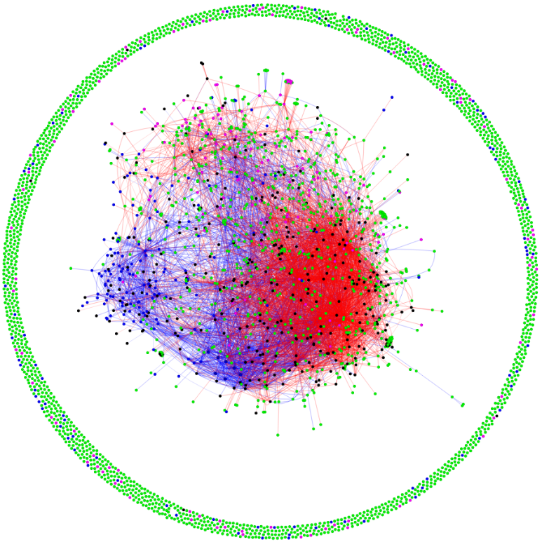

Figure 1: Green nodes- ICT firms; dark blue nodes- aerospace firms; pink nodes- AI firms; black nodes- research institutions, labs, universities and other intermediaries; blue links- vertical buyer-supplier relationships; red links- horizontal partnership relationships (joint R&D projects, joint collaborations, etc.).

The report also included highlights from Doloreux and Turkina (2019) when the scholars zoomed in on the AI-ICT clusters and explored how international giants that came to Montreal developed linkages with other firms located in Montreal (figure 2 below).
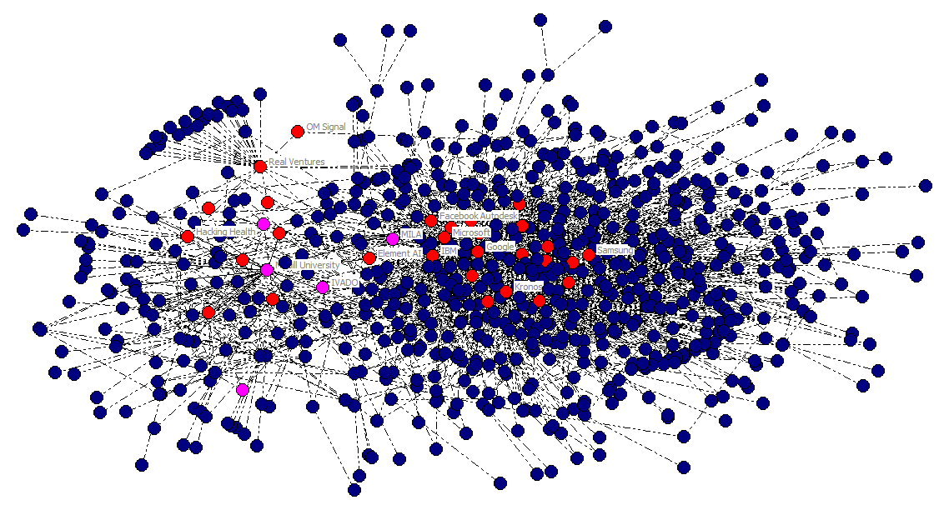
Figure 2: The network of relationships between AI (red) and ICT firms (blue), with
pink nodes representing research institutions and universities.

Their analysis indicated interesting trends. Structurally, Figure 2 can essentially be divided into two parts: local clustering (to the left) and international firms (to the right). An interesting feature of the network is that the AI nodes predominantly occupy a central position in both sub clusters, which implies that they have located in the critical places of Montreal’s ICT network. The local cluster is represented by such local AI players as Hacking Health, Borealis AI, Real Ventures, etc. ICT firms around them are essentially local too. At the same time, in the heart of the ‘international’ sub-cluster are massive multinational giants that came to Montreal to establish AI labs: Google, Microsoft, Kronos, Facebook, etc. All of these actors seem to capitalize well on the existing fabric of Montreal’s ICT cluster. There are important actors who play brokerage roles connecting these two sub clusters: research institutions such as IVADO and MILA, as well as Montreal’s local star firm Element AI, which is very well connected with the international cluster, the local cluster as well as research institutions and universities, placing it in a strategic brokerage place of the network. Another interesting feature of the network is existing partnership linkages among the AI companies within the respective sub-clusters, which indicates that the AI firms have pursued a double–pronged partnership model: establishing partnerships with the existing ICT firms and also forming intense partnerships with each other. This indicates that the AI cluster of Montreal did not emerge in a vacuum: Montreal had an important pre-condition in the form of a developed ICT cluster with a dense network of relationships, to which the new AI actors could attach and feed on. For example, Element AI greatly built on MILA’s expertise and on a partnership with Microsoft. Similarly, the new Facebook AI lab has tight connections with McGill University and several key AI and ICT actors.

Currently, there are over two 2 200 foreign subsidiaries in the Greater Montreal region that contribute to innovation and productivity, offering over 195 000 direct jobs and 200 000 indirect jobs (Montréal International, 2018). This accounts for 10% of all jobs and generates $4.1 billion in annual government revenue. Around 40% of all subsidiaries are part of 4 clusters: aerospace, life sciences and health technology, and information and communications technology/artificial intelligence (Montréal International, 2018). US subsidiaries represent almost half of all foreign subsidiaries and jobs in the Greater Montreal area. The French subsidiaries represent 12% of jobs. U.K. subsidiaries generate 8% of all jobs. While Montreal has already attracted the key international giants (Google, Facebook, Microsoft), it could do a better job creating more links between these firms and the purely local small firms and start-ups to further integrate these giants into the fabric of the cluster and initiate technological spillovers. Montreal could also continue to attract more international AI firms to locate in the local cluster.

Additionally, while international business seem to be already quite represented in Montreal’s AI cluster, internationalization of local firms to other perspective AI hubs and competitive foreign markets with strong AI seems to be quite a challenge. While Element AI has been successful in its internationalization, other firms have considerable difficulties exploring foreign markets due to the lack of resources, but also the lack of appropriate support programs.

Another important challenge is the development of general connections with other hubs in terms of joint events, conferences, etc. In 2018, Montreal hosted NeurIPS, the largest and the most prestigious conference in AI. Over 10 000 AI researchers came to Montreal to present their work and explore collaboration opportunities. Montreal also has a number of local conferences, forums and hackathons. At the same time, more effort could be directed towards the internationalization and popularization of the AI hub.

As an example from creative industries, in 2002, the city started to develop a vision to position Montreal as one of the best cities in North America and developed a comprehensive strategy where culture, research, technology, economy and knowledge would work together to make Montreal one of the most attractive cities in the world (Montréal International, 2005).

“In June 2006, Montreal was officially designated a UNESCO City of Design, joining the UNESCO Creative Cities Network. In giving Montreal this title, UNESCO acknowledged the city’s creative and technological potential in the design disciplines, based on the strong local concentration of talent as well as the commitment and determination of the Ville de Montréal, different levels of government, private firms and civil society to build on those strengths for the purpose of enhancing Montrealers’ quality of life.”

Montreal actively participates in many international cooperation activities with other cities in the field of design and creativity, sustainable urban development and cultural outreach. These activities help Montreal demonstrate its latest innovations and offer its firms access to new markets. Figure 3 below shows the network of international cooperation of the city of Montreal (Montréal UNESCO City of Design, 2016, pp. 1, 10).

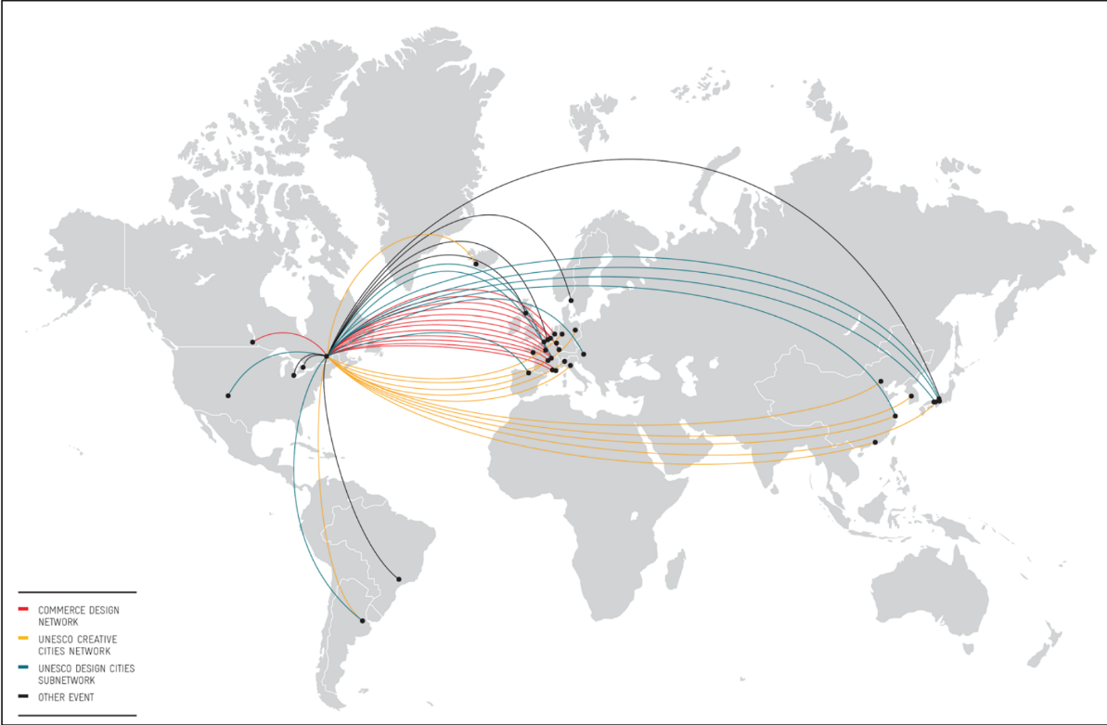
International Networking Co-operation (Montréal UNESCO City of Design, 2016)
Figure 3: Montreal’s international cooperation in creative industries

Another important challenge for Montreal’s AI hub is coordination of efforts to increase its international outreach. Other clusters such as Aero Montreal, Cleantech, and fashion and design have powerful cluster associations such as Écotech Quebec, Aero Montreal or Mnmode, which have teams of people working directly on helping local cleantech and aerospace firms internationalize, on attracting international investments into Montreal, and on creating projects for firms to strengthen collaborations. In the case of the AI cluster, there are several important initiatives and institutions such as Scale AI, IVADO, different consortiums and coaching programs (e.g. Element AI has a coaching program for new start-ups), but these efforts are disjointed and at present, there is no common strategy and cooperation structure that would make a strategic plan for increasing Montreal’s AI international outreach.

The report written by Nicolas’ research assistants also contained a great appendix providing a summary of major indicators for other global AI hubs (see appendix A).

Conclusion

Nicolas kept thinking about the report prepared by his assistants and the ideas that he stemmed from his analysis. He couldn’t wait to share these ideas at the upcoming meeting. He was also very eager to listen to his colleagues and partners’ ideas. He was certain that together, they would develop a winning strategy on how to increase Montreal AI hub’s international outreach and visibility!

Task

Help Nicolas, his team at Investissement Quebec, partners and broader stakeholders develop a comprehensive strategy for enhancing Montreal AI hub’s international dimension: How can Montreal continue to attract high-performance firms from abroad and better integrate them into the fabric of the local cluster? How can it help local firms grow and internationalize (and what should the priority markets be)? How can it increase the international visibility and popularity of the local AI cluster?

References

Bathelt, H., Malmberg, A., Maskell, P. (2004). Clusters and knowledge: local buzz, global pipelines and the process of knowledge creation. Progress in Human Geography, 28(1): 31-56.
Dalum, B. (1995). Local and Global Linkages: The Radiocommunications Cluster in Northern Denmark. Journal of Industry Studies, 2(2), 89-109.

Dalum, B.; Pedersen, C. Ø. R., Villumsen, G. (2002). Technological Life Cycles: Regional Clusters Facing Disruption. Aalborg: DRUID Working Paper Series, No. 2002-10.

Dalum, B., Pedersen, C. Ø. R., & Villumsen, G. (2005). Technological Life-Cycles, Lessons from a cluster facing disruption. European Urban and Regional Studies, 13(3), 229-246.

Doloreux, D. and Turkina, E. (2019). (New) Industrial path development and Artificial Intelligence industry in Montreal: actors, path-dependency and policies, working paper

Porter, M. (1998). Clusters and the new economics of competition. Harvard Business Review, 76(6), 77–90.

Turkina, E.,Van Assche, A., Kali,R. (2016). Structure and evolution of global cluster networks: evidence from the aerospace industry », Journal of Economic Geography, vol. 16, no 6, 2016, p. 1211-1234.

Turkina, E.,Van Assche. A. (2018). Global connectedness and local innovation in industrial clusters. Journal of International Business Studies, 49: 706.

Turkina, E.,Van Assche, A., Doloreux, D. (2019). A Tangled Tale of Cluster Co-Location in Greater Montréal, working paper.

Appendix A

Cluster | # ICT + AI firms  (1) | # AI firms  (2) | Composition firms:  a) Large MNE  b) Local MNEs  c) SMEs  d) Start-ups  (3) | # research institutions & universities  (4) | Name of major institutions & universities  (max 5)  (5) | Location quotient (AI & ICT clusters)  (6) | Data on patents & publication produced  (country/institution)  (7) | Job creation  (employment/  Openings  (8) | R & D  (9)
Montreal | ICT:  5240 | 250+ | a)15+  b)5  c)  d) 250+ | 13+  (R labs: 5) | 1.McGill university  2.Element AI  3.MILA  4.IVADO  5.CRIM | 1. IT 1,3  2. Ed. & knowldg. creation 1,3  3. ICT 1,6 | 1. 1% Canada share of world PT app.)  2. Published papers by country  61 782 | 1. AI job creation 600-700, + 130 (2019-2021)  2. 13% of AI Canadian jobs  3. ICT #  120 000  4. Labor pool AI-related 92 800 | 1. 1.1Bn $ (CAD$)
Toronto | ICT: 14 000 | 350+ | a) 5+  b)115+  c)  d)350+ | 1. 10 public research labs  5 academic labs  2. 11+ (both) | 1.Toronto & Ryerson Universities  2. CIFAR  3.Vector Institute for AI  4.Borealis AI (RBC)  5. DCSIL  *firm | 1. IT 1.4  2. Ed. & knowldg. Creation 0.7  3. ICT 2.2 | *see Montreal (data available only at the country level) | 1. ICT employees 400 000  2. Ed. & knowledge creation  60 000  3. 37% of AI Canadian jobs | 1.Recent 100M $ from Vector institute  2. Gov. + private 80M $  Total recent 180M $  (CAD$)
Silicon Valley  (San Francisco, San José, Palo Alto, Mountain view) | IT: 2 033 | 1.Total 534  2.SF 289,  SJ  46,  PA  106,  MV  51 | a) 10+  b)15+  c) 30+  d)167+  *US based giants | 15+ | 1.Stanford University  2.Berkeley (U of C)  3. UIUC  4. University of Waterloo  5.Microsoft (Silicon Valley campus)* | 1. IT total 3.47  2. IT  (SF) 3.11  3. IT (SJ) 5.5 | 1. (USA) 24.8% of world patents applications  2.(USA) AI patent publications granted to universities 241  3. Published papers by country 369 588  4. number of publications (AI)  Microsoft USA  2 648  IBM: 2 351  Stanford:  2 235  5. AI patent application (2018) 644  6.AI portfolio patent application IBM  8 290,  Microsoft 5 930 | 1.IT Employment total  150 325  2.(SF)  77 871, (9.6% AI)  3. (SJ)  76 871, (9.2% AI)  4.Job creation  25 928 (2010-2016) | 1.$9.9B (total funding)  2.$6.3B (investment)  3. Startup investment (2017) $3.4Bn  4. (SF) VC funding total  £11.44Bn
New York | IT: 1 542  Tech companies  & startups  26 421 | 1.  188,  2. 367  (two data sources) | a)55  b)  c)  d) 63 | 10+ | 1.IBM Thomas J Watson Research Center  2.Colombia University  3.University of New York  4. Microsoft Research lab (NYC)  5. Google AI | IT: 0,75 | Patent IT 3 324 | 1. IT: Employment 79 470  2.Job creation  3,309  (2010-2016)  3. AI related 11.6%  4.AI jobs available  1 000 | 1.Total: $2,6Bn  2. VC funding total  £3.05Bn
Boston | IT: 1 336 | 117 | a)10+*  b)  c)  d)102 | 10+ | 1.MIT  2. Harvard university  3. Tufts university  4.University of Massachusetts  5. Cambridge IBM Research Center | IT: 2,61 | 1. Patent IT  2 432  2. number of publications by MIT: 2 312 | 1.IT employment 81,159  2.IT job creation  3,660  (2010-2016),  3. (AI related 6,1%)  4. AI job creation  2 000+ | 1.IBM $240M investment  2. VC backed companies $4,7Bn (2016)
London | 1. ICT 68 875  2. Computer programming; consultancy and related activities  46,670 | 1. 275,  2.  187  3. 551 | a) 15+  b)36+  c)  d)46, 211 | 13+ | 1.UCL  2. Alan Turing Institute  3. Deepmind  4. The centre for doctoral  training in financial computing & analytics  5. Imperial College London’s  * | 1. ICT: 2.2  2. Professional, scientific and technical activities  1.7  3.Science and technology 1.5-5  4.Scientific R&D 0.75 | 1. World patent applications  1.3 %  2. Papers published by country  96 536 | 1.AI jobs available  1 038  2. AI experts 22 000  3. employed in digital technology 250 000 (2017)  4.AI job creation 500+ | 1.  500 M +2,5Bn+21 M  2.  £ 1.31Bn (2017)  3.Gov. & ind. Strat.  £ 4,7Bn by 2021  4. VC funding total  £839.96M
Berlin | ICT: 9 700 | 48 | a)8+  b)20  c)  d)51, 56 | 10+  (4 uni) | 1. Max Planck Institute  2. Fraunhofer Gesellschaft AISI  3. Helmholtz Association of German Research Centres  4.BBDC  5. The German Research Center for AI (DFKI) | 1.ICT:1.4  2.Ed. & knowledge creation 2.1  (2011) | 1. world patent applications 2.7%  2. Papers Published by country: 85 587 | 1.AI jobs available 261  2.ICT job creation (2017)  2 976  3.ICT employees 96 000  4.Tech workers population growth Germany 4%  5. AI job per 1M total in the city 676.8 | € 1.3Bn until 2025  2. € 30M in public funding to flow in the German AI hubs from 2018  3. VC funding total  £87.62M
Beijing  (China) | ICT  83 330+ | 412,  395 | a) 20+*  b)30+, 40 unicorns  c)  d) 150  1. R&D activities number firms:  foreign 146, state owned 10, domestically invested firms  1 145 | 1.200+ research institutes, 40+educational institutions  2.Engineering and technical Science institutions: 1 619  3.Higher education science and engineering: 31 | 1. Tsinghua University  2. CAS  3. Beijing institute of technology  4. BJUT  5. Beihang University (BUAA)  * | X | 1.Published papers by institutions (CAS) 9 064  2.Patent applications Beijing (2018) 11 350  3. World patent app. by country  31.1%  4.China AI patents publications granted to universities 725  5.Published papers by country 327 034  6.AI patents owned by entity: State Grid Corporation of China 4 246, Baidu 542, Chinese Academy of Sciences System 897 | 1. R&D employed 338 000  2. total scientific and technological activities employed 735 847  3. employed in science and technology  220 446  4.AI jobs available 133 | 1.$2.3Bn  2. China government more than $7Bn in funding  3. China government R&D  (2018): over $2Bn (AI research park)  4. Total R&D expend. ¥159.5Bn (Yuan) High tech sector  5. internal R&D expend.  ¥ 29,3Bn (Yuan) year 2017  6. VC funding total  £3.57Bn (pounds)
Bangalore  (India) | IT 8 000+ | 18 | a)5+, (IT)61+  b) (IT) 31  c)  d) 200+  *more than 200 AI start-ups in India | 10+ | 1.CAIR  2.DRDO  3.IISc  4.CoE-DSAI  5.NASSCOM  * | X | 1.Published by country: 75 128  2. India papers in 2016: 3 301  3. ISS Bangalore ublications 7,58% | 1. AI jobs available 1500+  2. India:  4 000 AI available  3.. IT over 1 million employees  4. job creation 150 by end of 2019 | 1.VC funding  $67M (2017)  2.VC funding total  £ 136.67M

Information taken from Doloreux and Turkina, 2019
https://www.aeromontreal.ca/
Écotech Québec. (2018). “About us.” Retrieved from: http://www.ecotechquebec.com/en/about-us/vision-mission-and-actions/
https://www.investquebec.com/international/en/secteurs-activite-economique/technologies-information-communications/Montreal-s-Artificial-Intelligence-Hub.html
https://www.cbc.ca/news/technology/montreal-element-ai-102-million-funding-yoshua-bengio-1.4159602
Gagné, Jf. (2018). Canadian AI Ecosystem. Retrieved from http://www.jfgagne.ai/blog/the-canadian-ai-ecosystem-in-2018
SCALE AI. (2018). CISION: $290 million in support for SCALE AI, the AI-powered Supply Chains Supercluster. Retrieved from https://www.newswire.ca/news-releases/290-million-in-support-for-scale-ai-the-ai-powered-supply-chains-supercluster-702086202.html
Ibid
https://www.newswire.ca/news-releases/290-million-in-support-for-scale-ai-the-ai-powered-supply-chains-supercluster-702086202.html
http://www.montrealintechnology.com/montreal-universities-get-213-million-ai-big-data/
https://www.thestar.com/business/2018/12/04/montreals-ai-hub-attracts-three-uk-companies-and-130-jobs.html
https://www.thestar.com/business/2018/12/04/montreals-ai-hub-attracts-three-uk-companies-and-130-jobs.html
For more information about AI activities in Montreal, please see here: https://www.eventbrite.ca/d/canada--montreal/ai/
Example taken from 2018 IGC case on Smart Cities
Extracted from: https://designmontreal.com/en/montreal-unesco-city-of-design
MILA: Montreal institute for learning algorithms
number of ICT employer businesses by 1 000 residents
CIFAR: Canada Institute for advanced research
DCSIL: Toronto Department of Computer Science Innovation Lab
MNEs such as Uber, Samsung, IBM (research labs), Google, Element AI
number of ICT employer businesses by 1 000 residents
Google, Amazon, Facebook, Apple, Intel, IBM and Microsoft.
Another important is PARC (Palo Alto Research Center)
Percentage (%) of AI jobs out of all job posting in the city/region (Same for SJ, Boston, NYC)
Others such as Samsung AI research center, Cornell University, AI now institute
Giants such as Amazon, google, IBM, GE, facebook, microsoft, twitter
MIT: Massachusetts institute of technology: Computer Science & Artificial Intelligence Lab (CSAIL)
UCL : University college London
Oxford University as well
Berlin big data center
State level development zone (uni)
Leading firms include DJI, UBTech, Sense Time, cambricon, Alibaba, Baidu, Tecent, Lenovo :
Basic information on R&D activities of information transmission, software and information technical services enterprises
Above designated size enterprises: it means (in China) industrial enterprises with annual main business revenue of 20 million yuan or more.
CAS: Chinese Academy of Science
BJUT: Beijing university of technology
Other important ones Pekin University, Google AI center, Zhongguancun science park, Ministry of Industry & Information Technology (MIIT), Baidu AI park
Annexe 1: Global data base Excel
India’s Center for Artificial Intelligence & Robotics (CAIR): Defence Research and Development Organisation (DRDO)
Indian institute for science
Centre of Excellence for Data Science and Artificial Intelligence
National association of software and services companies, other important ones Indian International Institute of technology (IIIT) & Global Artificial Intelligence Accelerator (GAIA)
India: Xerox Research, IBM Research, TCS Innovation Labs and Microsoft Research

