Montreal’s artificial intelligence (AI) cluster:
Developing a winning branding strategy!

Introduction

Despite the early hour one snowy January day, Patricia Amacifuen Vilchez had already woken up to work on her report for Montreal International and Investissement Quebec. Montreal International is Greater Montreal’s economic development agency for foreign investment, international organizations and strategic talents. Investissement Quebec is an organization that helps to attract investment in Quebec by Quebec-based and international companies.

Patricia, a master’s student at HEC Montreal, was doing a joint project with these two organizations with regard to developing a branding strategy for Montreal’s artificial intelligence hub.

In her report, Patricia conducted a thorough analysis of the local AI eco-system and identified strong points that should be used for developing a sound marketing strategy. She also explored how other artificial intelligence hubs, notably Silicon Valley, branded themselves to find interesting ideas that could be applied in Montreal too. Her project was advancing very well—so well, in fact, that her agitation and excitement woke her up very early and compelled her to continue working on the report.

Photo: Amacifuen Vilchez

Montreal AI hub

Over the past several years, Canada has emerged as one of the most influential countries in the field of artificial intelligence, boasting several advanced AI clusters, notably in Montreal, Edmonton and Toronto. From 2017 to 2018, there was a 28% increase in the number of active AI-related start-ups (over 650) across all cluster cities. The last few years have also seen a sharp increase in the number of large international players setting up their AI labs in Canadian cities. In particular, the main cluster cities (Montreal, Toronto, Vancouver) have seen tech giants (e.g. Google, Uber, Facebook, Thales, Microsoft) opening research labs, adding to already highly active research communities. With these developments, Montreal emerged as one of the leading artificial intelligence tech clusters in the world and the leading location in the world for a subset of AI: deep learning.

Innovation clusters have been defined as “regional concentrations of large and small companies that develop creative products and services, along with specialized suppliers, service providers, universities, and associated institutions. Ideally, they bring together a critical mass of skills and talent and are characterized by a high level of interaction among these entrepreneurs, researchers, and innovators” (Wessner, 2011). These clusters are sometimes referred to as technological districts or knowledge clusters (Braczyk et al, 1998; Malecki and Oinas, 1999; Lorenzen and Foss, 2002). Innovation is geographically concentrated in areas with agglomeration economies that offer a high local density of specialized resources, which enhances and facilitates the innovation process (Muro and Katz, 2010). According to Scott (1988), the formation of agglomerations is particularly intense in R&D intensive industries where flows tend to be small-scale and unpredictable, and hence subject to high transaction costs.

Montreal’s artificial intelligence ecosystem is formed by local and international companies that share knowledge inside and outside the local cluster, stimulating collaboration and creation. Element AI, a Montreal-based firm launched in 2016, quickly became a true born-global start-up. It has opened offices and is hiring in Toronto, Seoul, Singapore, Tokyo, London, and plans to expand further. Born-global firms, from their inception, have a global focus and commit their resources to global expansion (Freeman & Cavusgil, 2007). Most companies explore their domestic market for years and then slowly evolve to engage with international markets. By contrast, born-global firms view the world as their marketplace and very early take measures to expand abroad (Knight and Cavusgil, 2004). Element AI’s products and services address all the AI needs of an organization—from strategic roadmapping and ready-to-deploy applications, all the way to implementation of transformative business solutions through the company’s AI-as-a-Service (AIaaS) platform. Since its launch, Element AI has experienced exponential growth, and quickly became the largest artificial intelligence company in Canada, the largest privately owned R&D lab in the world, and the fastest growing start-up in the artificial intelligence segment globally. The company already employs around 500 people. It is also important to note that Element AI had the world's largest Series A funding round ever for an artificial intelligence company, collecting over $100 million in funding. At present, Element AI aggressively expands on a global scale focusing on “AI-powered solutions for their customers in cybersecurity, fintech, manufacturing, logistics and transportation, and robotics.”

In addition to Element AI, Montreal’s AI cluster boasts over 250 local AI firms, as well as major international giants—including Google, Microsoft and Facebook—who opened AI research labs in the city over the last three years.

An important factor that contributed to Montreal’s emergence as a world-class AI cluster is the availability of a highly educated workforce. With its world-class universities and especially advanced programs in computer and electrical engineering, operations research and decision sciences, every year Montreal has a very high number of tech graduates. For instance, there are more than 250 researchers in deep learning in McGill University and the University of Montreal—the biggest concentration in the world. In 2017, Montreal was ranked the top city in the world for students. Additionally, there are several advanced research institutions in Montreal such as IVADO (Institute for Data Valorization) that offer postdoctoral research opportunities to new graduates.

Among the most notable Montreal AI cluster developments are:

- In 2019, Montreal’s professor Yoshua Bengio, the head of Montreal Institute for Learning Algorithms (MILA), received a Turing prize, which is the equivalent of Nobel prize in computer science. He received it together with Geoffrey Hinton (Toronto) and his student Yann LeCun (educated in Toronto, now working in NYC). These three scholars are frequently referred to as the fathers of deep learning. Many proclaimed the fact that the Turing award was given to these scholars indicates the victory of Canadian AI education.
- Thales SA opened an AI lab in Montreal in collaboration with MILA. They plan to hire 50 AI scientists by mid-2019.
- The Royal Bank of Canada opened a Borealis AI lab in 2018. They hired 10 researchers on staff in the first year and plan to expand rapidly.
- Samsung Electronics’ Advanced Institute of Technology (SAIT) opened an AI lab in the University of Montreal in August 2017. SAIT has been collaborating with Yoshua Bengio and other partners from the University of Toronto, McGill University and NYU since 2014.
- Google Brain recruited former student of Yoshua Bengio and Montreal native, Hugo Larochelle, in mid-2017, to run their AI research in Montreal. Montreal’s Google AI lab is rapidly growing.
- Facebook established an AI research lab in Montreal in late 2017 and hired Joelle Pineau (a McGill University Professor of Computer Science) to lead it. The lab initially hired 10 researchers, and tripled in size by the end of 2018. The lab is developing new ways to implement AI, especially for defining messages, screening spam and understanding voice commands in virtual reality.
- DeepMind, acquired by Google in 2014, opened an AI research lab in Montreal in October 2017. It is headed by Doina Precup (McGill University Professor of Computer Science).
- Microsoft acquired Montreal AI lab, Maluuba, in early 2017 and doubled the number of its technical experts within a short span of two years.
- Yoshua Bengio and a team of experienced tech entrepreneurs launched Element AI in 2016.

Figure 1 below shows Montreal on the map of the leading global AI hubs. The US and Chinese hubs lead in terms of AI investments and the total number of firms. Toronto is the largest hub in the world in terms of start-up growth and new AI job creation. Montreal is leading world’s hub in research.
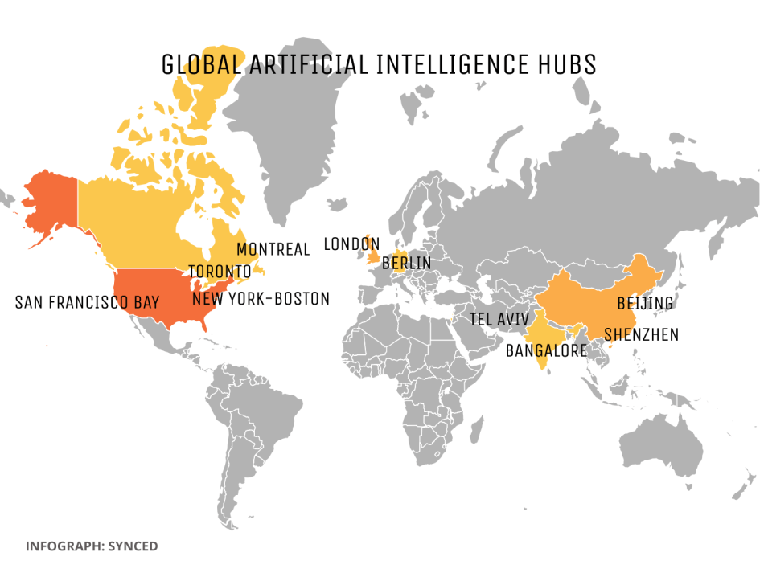
Figure 1: Global AI hubs

Montreal’s AI sector has also received massive investments by the Canadian federal government (through the $125 million Pan-Canadian artificial intelligence strategy, $900 million research excellence fund and $950 million supercluster initiative) and provincial government (to the order of hundreds of millions). Furthermore, Valerie Plante, the mayor, has earmarked $360 million in business and entrepreneurship in Montreal over the next four years to bolster Montreal's economy. Additionally, Montreal universities received $213 million for research in artificial intelligence.

Moreover, the city of Montreal is also well-positioned in the rest of the Information and Communication Technologies (ICT) sector with over 5 000 dynamic ICT firms. The city is one of the top ten cities in North America in terms of ICT jobs; it has more than 91 000 employees and 14 000 students in fields related to ICT (Montréal International, 2018). In addition, Montreal is one of the 5 leading global video games clusters, which has experienced a 14% annual growth in jobs in the last 10 years (Montréal International, 2018). Montreal has attracted a selection of leading game developers and publisher studios such as EA, Eidos Interactive, Artificial Mind and Movement, Bioware, and Strategy First.

Table 1 below shows the companies present in Montreal that stand out internationally in the ICT sector.

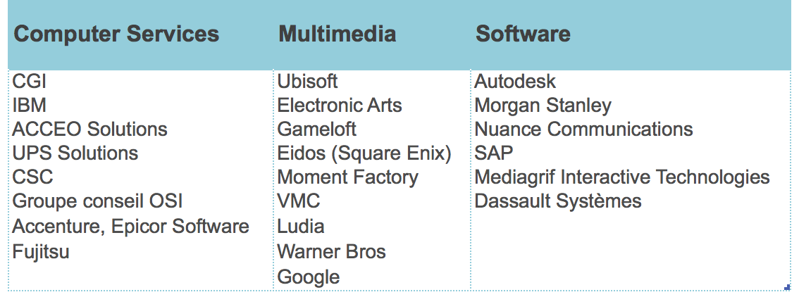
Note. Table created with information provided by Montréal International (2018b)
Table 1: Leading ICT firms

Montreal has several other tech clusters. Aéromontreal, a cluster in the aerospace industry with around 400 high-performance firms, is third biggest world’s aerospace cluster after Toulouse and Seattle. Montreal also has a very advanced Écotech cluster (green industry) represented by over 1 000 cleantech organizations and a very proactive cluster association, Écotech Quebec. The city has also been famous for its design and fashion cluster (Mmode), as well as creative industries, especially in the field of creative digital technologies and digital art.

Recently, when the computational power and availability of big data caught up with the fundamental research in AI, different industries realized big commercial potential in AI models developed by fundamental scientists. As a consequence, Montreal has become a global hotspot in the new emerging AI industry.

Some important AI cluster promotional initiatives and attempts
at cluster branding

Unlike other more mature clusters such as Écotech, Mmode or Aéromontreal, the young Montreal AI hub does not yet have a cluster association that would help to promote it. For instance, Écotech Quebec and Aéromontreal regroup major industry leaders and have dedicated teams of employees specifically working on helping local cleantech and aerospace firms to collaborate, grow, scale up, commercialize their innovations, and internationalize. These cluster associations are also instrumental in attracting international investments to Montreal. These associations have also powerful branding strategies for their respective hubs, including intense work with mass media and the development of comprehensive websites that inform the public about major cluster developments, give quick access to information about major cluster stakeholders, etc.

As the development of the AI cluster accelerated, and the financial support (both public and private) rolled in, the City of Montreal joined forces with such organizations as Montreal International, Investissement Quebec and Montreal Chamber of Commerce to launch some efforts to build infrastructure to serve local AI start-ups and research labs. These organizations also started to work on attracting more AI talent and investment into Montreal.

The City of Montreal and its partners came up with the following approach: Montreal AI-First Conglomerate: A Win-Win Approach. Under Montréal.AI’s umbrella, multiple companies and organizations are being structured to apply hugely impactful AI technologies in ways never thought of and to launch emerging startups. This umbrella unites different initiatives aimed at promoting Montreal’s AI hub:

- Montréal.AI Academy
  - Training the individuals who, with AI, will shape the 21st Century.
- Montréal.AI Fine Arts
  - Pioneering legendary fine AI arts opening the doors to the AI art movement.
- Montréal.AI Consulting
  - Consulting the right AI leader can significantly increase your odds of business success.
- Montréal.AI Space
  - Enhancing Humanity’s well-being by leveraging superintelligence to explore the Stars.
- Montréal.AI Web
  - Deploying artificial intelligence and ML models on the World Wide Web

Montreal International also posted a promotional video titled Montréal, an Artificial Intelligence Powerhouse, which features several headliners in the industry, including Yoshua Bengio (University of Montreal), Doina Precup (McGill University), Hugo Larochelle (Google Brain), Yann LeClun (Facebook), as well as the Prime Minister of Canada, Justin Trudeau. The video highlights all of Montreal’s advantages and the deep collaboration between research chairs, laboratories and entrepreneurs.

Link to the video:
http://www.montrealinternational.com/en/greater-montreal-a-driving-hub-of-artificial-intelligence/

Montreal stakeholders also organized a number of impressive AI events:

In January 2018, the Chamber of Commerce of Metropolitan Montreal held its first Strategic Forum on Artificial Intelligence in order to discuss AI’s immense progress, mobilize the business community and promote the creation of a supercluster. Following the resounding success of this first gathering, the Chamber organized the second edition of this Forum (February 18, 2019), and has plans to establish this as an annual event.

In 2018, Montreal also held a huge international AI Symposium that gathered experts and professionals interested in fundamental advances and applications of artificial intelligence, with an emphasis on machine learning, deep learning and related approaches. The Symposium welcomed both academic and industrial participants; it seeks to build strong connections between researchers within the Greater Montreal area.

In 2018, the city also hosted NeurIPS, the largest and the most prestigious conference in AI. Over 10 000 AI researchers came to Montreal to present their work and explore collaboration opportunities. As part of the strategy to further promote Montreal as an AI hub, Montreal airport changed its label on the main building to accommodate the AI abbreviation (photo 2).

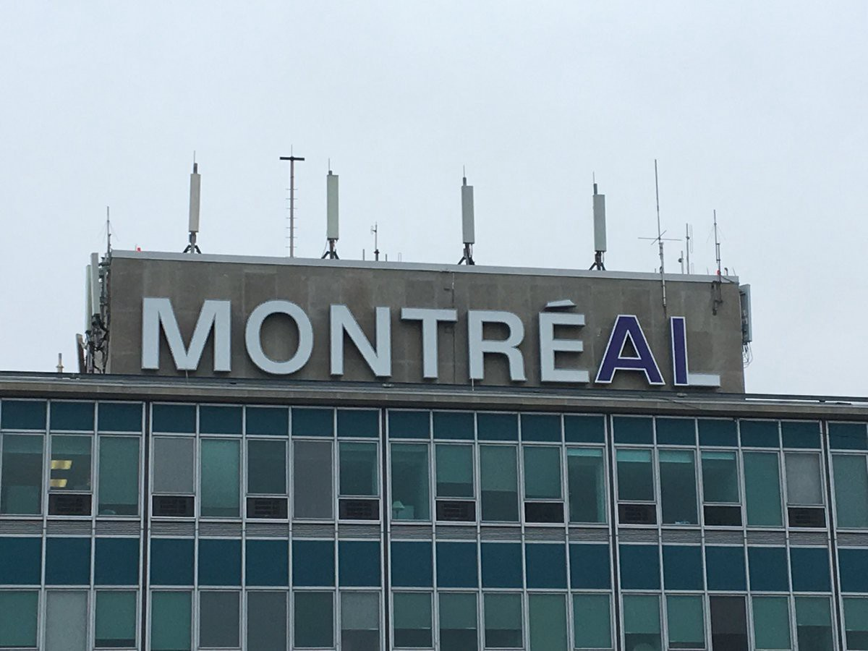

Photo 2: Montreal airport during NeurIPS Conference.

Element AI has been working with various stakeholders to organize an annual AIFest: a two-day event which explores the future of AI and its impact on society and business. “Held in Montreal, the AI hub of Canada, the event brings together the brightest minds from the start-up and AI worlds to share perspectives on artificial intelligence trends, predictions and issues.”

Montreal also launched a deep learning summit. “The summit explores the latest research findings in deep learning and the real world impact these may have.” The summit boasts of a global line-up of experts that present on the latest progress towards technological advancements.

Moreover, two massive AI events will be hosted by Montreal in the near future:

“The Palais des congrès de Montréal [Montreal Convention Centre] will be hosting two artificial intelligence (AI) conventions, more evidence of just how dynamically this scientific field is developing in Montreal. The 30th International Joint Conference on Artificial Intelligence (IJCAI) will be coming in 2021 and will attract nearly 3 000 experts from all over the world. This means a total of nearly 8 400 room nights booked in Montreal hotels and over $4.5 million in tourism revenue for Quebec.”

Montreal has also developed a number of local AI events, forums, hackathons, and conferences.

There have also been some private promotional initiatives. The most famous ones are Element AI’s Podcasts titled ‘The AI Element.’ During each 20-minute episode, the top influencers across multiple industries sit down to investigate how AI is being used to disrupt and innovate the way business is being conducted today. Through these conversations, the key AI leaders help to explain what technology can actually do for business. The podcast is available on the following platforms: Apple Podcasts, Google Play, Spotify, Stitcher, Overcast, SoundCloud, Player FM, Pocket Casts, and different android apps.

The first season of ‘The AI Element’ consists of six episodes and features AI though leaders such as Yoshua Bengio, Head of the Montreal Institute for Learning Algorithms (MILA), and industry veterans such as Chris Benson, Chief Scientist for Artificial Intelligence & Machine Learning at Honeywell Safety & Productivity Solutions. The first episode titled ‘What AI Can’t Do’ discusses how societal hype around AI is a byproduct of a few recent scientific breakthroughs—speech recognition, computer vision, natural language processing. See here for a full list of episodes and access to the podcast: www.elementai.com/podcast.

To further promote AI to the general public, MILA, in collaboration with the Fonds de recherche du Québec, developed the Montréal Declaration for Responsible Development of Artificial Intelligence. This set of ethical guidelines for the development of artificial intelligence is the culmination of more than a year of work, research and consultations with citizens, experts, public policymakers and industry stakeholders, civil society organizations, and professional orders.

The city also offers generous tax benefits and grants to companies in tech sectors. It is important to note that in 2017, Montreal obtained Metropolis status, giving it more funding opportunities and autonomy. On the economic level, Montreal got more power to grant direct subsidies and tax credits to companies that want to invest in the city. That power came with a $50-million-a-year development fund the city can use as it sees fit. These developments also favored an influx of foreign tech firms into the city.

Montreal has lower GDP per capital than competing Toronto and US cities, but compensates with much cheaper rents, affordable housing, a rich local culture, a creative local environment, and high living standards.

While working on her report, Patricia thought that while Montreal organizes and hosts a significant number of AI events and promotional activities, more effort could be directed towards creating more publicity and more initiatives that would expose Montreal to the international AI communities.

How do other AI hubs promote themselves?
A comparison with the major competing hub Silicon Valley

Silicon Valley, one of the major AI hubs, has a number of powerful international AI events. It hosts the annual Orange Silicon Valley conference that brings together industry luminaries and Orange Silicon Valley partners to discuss how advances in machine learning, machine vision, conversational AI, and cybersecurity are transforming business. Silicon Valley also hosts AI Innovation Summit, Silicon Valley AI Summit, the world’s first and largest conference and exhibition, to look at the practical implications of AI; it joins over 150 investors, AI experts, and leading AI companies who will share their insights on this rapidly growing sector and the disruptive technologies paving the future of A.I. It also hosts the famous NextCon conference, which is the leading technology conference for AI, Cloud, and Data technology taking place around the world. It brings together top technical engineers, practitioners, influential technologists and data scientists to share their solutions and practical experience in tackling engineering problems.

At the federal level, in 2019, President Donald Trump used an executive order to launch a new commitment to the development of artificial intelligence in the United States—an effort to maintain America’s lead in the industry.

Silicon Valley also uses an effective communication strategy by coining the so-called buzz words that AI specialists across the globe then use in their lexicon:

“Before delving into said baggage, Silicon Valley marketing types use the keyword AI to represent the machine learning technological movement. Much like its buzzword predecessors the Information Superhighway, the .com era, Web 2.0 or Big Data, AI represents the next significant promise from technology companies.”

“The word ‘moat’ is the latest buzzword in Silicon Valley and it’s appearing more often in the business pages. The trend is not as odd as it might appear. Tech company executives have used the word ‘moat’ 89 times in earnings calls and financial presentations over the past year. The trend appears to be tied back to Warren Buffett’s choice of the metaphor as a stock picking analogy. Buffett said he looks for companies that have a strong protection against competitors, ‘like an economic castle’.”

Moreover, Silicon Valley has its own business journal:
https://www.bizjournals.com/sanjose/news/ , several electronic newspapers (e.g. https://www.siliconvalley.com/), as well as the Netflix series, Silicon Valley, which is an American comedy television series created by Mike Judge, John Altschuler and Dave Krinsky. The series focuses on five young men who founded a start-up company in Silicon Valley.

The powerful AI hub also has several strong PR and advertising companies that work specifically on its promotion (see figure 2 below).

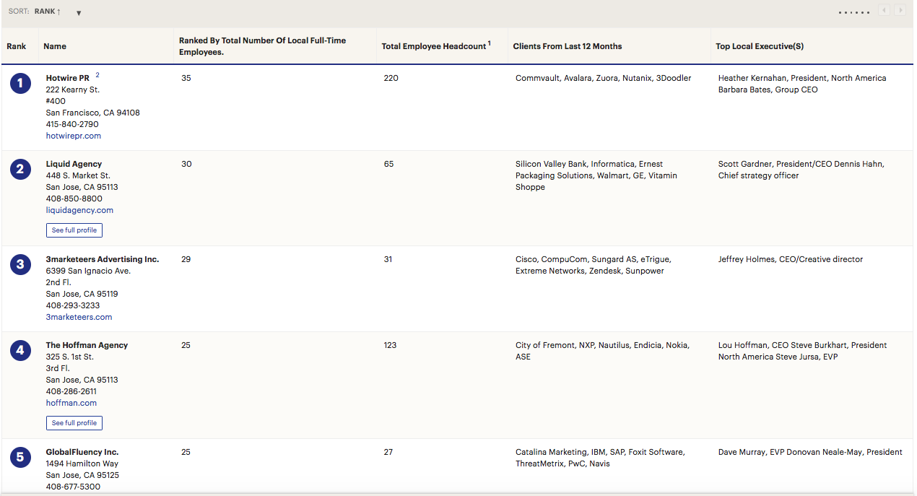
Figure 2: Downey, Osie. (2018) Silicon Valley's largest advertising, marketing and PR agencies. Retrieved from
https://www.bizjournals.com/sanjose/subscriber-only/2017/08/04/largest-advertising-marketi
ng-and-pr.html

An important recent development in the hub is that Google, Facebook, IBM, Amazon, and Microsoft are launching a new non-profit organization dedicated to developing the public’s understanding of artificial intelligence as well as establishing ground rules for researchers to use in future projects. The name of the organization is the Partnership on Artificial Intelligence to Benefit People and Society. Its board will have equal representation with members coming from the corporate and non-corporate sectors.

“We’re in a golden age of Machine Learning and A.I. As a scientific community, we are still a long way from being able to do things the way humans do things, but we’re solving unbelievably complex problems every day and making incredibly rapid progress,” said Ralf Herbrich, Amazon’s Director of Machine Learning Science and Core Machine Learning, in a statement. “This partnership will ensure we’re including the best and the brightest in this space in the conversation to improve customer trust and benefit society. We are excited to work together in this partnership with thought leaders from both industry and academia.”

The organization is not planned to be a lobbying-type organization, but specific tasks will focus on supporting research in areas such as trustworthiness, reliability, and robustness of technology, as per the Partnership’s announcement.

Other aspects of the partnership’s agenda include introducing a platform to promote an open discussion of how A.I. will impact fields such as telecommunications, manufacturing, and finance, and will feature important players in these industries.

Conclusion

Patricia kept working on the report and thinking about the project. She was really excited about this challenge! She believed that she succeeded in conducting a solid overview of AI promotional activities in Montreal, as well as in the major competing hub: the Silicon Valley. While working on this project, Patricia also generated some ideas of a possible unified marketing strategy for the Montreal AI hub.

Task

Help Patricia and major Montreal AI stakeholders develop creative and comprehensive promotional strategy for the Montreal AI hub!

References

2018 Symposium AI Montreal. (2018) News. Retrieved from http://montrealaisymposium.com

AI Future of Work. (2018). AI Innovation Summit 2019. Retrieved from https://analyticsevent.com/aisummit2019/

Bushey, Ryan. (2016) Silicon Valley Giants Create Nonprofit to Promote A.I. Ethics. Retrieved from https://www.rdmag.com/article/2016/10/silicon-valley-giants-create-nonprofit-promote-ai-ethics

Braczyk, H. J. (1998). Regional innovation systems. London: UCL Press.

C2 Montréal. (2018) The AI Forum 2018: Taking the next bold step. Retrieved from https://www.c2montreal.com/menu/the-ai-forum-at-c2-montreal-2018/#/

Downey, Osie. (2018) Silicon Valley's largest advertising, marketing and PR agencies. Retrieved from https://www.bizjournals.com/sanjose/subscriber-only/2017/08/04/largest-advertising-marketing-and-pr.html

F50. (2018) SILICON VALLEY : AI SUMMIT. Retrieved from http://f50.io/svaisummit/

Financial Post. (2018) Element AI Announces New Podcast Series 'The AI Element. Retrieved from https://business.financialpost.com/pmn/press-releases-pmn/business-wire-news-releases-pmn/element-ai-announces-new-podcast-series-the-ai-element

Freeman, S. , & Cavusgil, S. T. (2007). Toward a typology of commitment states among managers of born global companies: A study of accelerated internationalization. Journal of International Marketing, 15(4), 1–40.

Gallo, Carmine (2018) A Trendy Silicon Valley Buzzword Offers A Valuable Lesson In Effective Communication. Retrieved from https://www.forbes.com/sites/carminegallo/2017/05/21/a-trendy-silicon-valley-buzzword-offers-a-valuable-lesson-in-effective-communication/#85f3dd856ceb

Knight, G. , & Cavusgil, S. T. (2004). Innovation, organizational capabilities, and the born global firm. Journal of International Business Studies, 35(2), 124–141.

Livingston, Geoff. (2018) Artificial Intelligence: The Most Unfortunate Buzzword. Retrieved from https://medium.com/datadriveninvestor/artificial-intelligence-the-most-unfortunate-buzzword-a5f0b678a7b1

Lorenzen, M., Foss, N. (2002). Cognitive Coordination, Institutions, and Clusters: An Exploratory Discussion, In Brenner (ed.), The Influence of Cooperations, Networks and Institutions on Regional Innovation Systems. Cheltenham: Edward Elgar.
Mamo, Joanna. (2018) AI, eh? 3 Reasons Why Artificial Intelligence in Canada is Red Hot Right Now. Retrieved from https://ianmartin.com/ai-eh-3-reasons-why-artificial-intelligence-in-canada-is-red-hot-right-now/

Malecki, E., Oinas, P.(eds.). (1999). Making Connections: Technological Learning and
Regional Eeconomic Change, Aldershot: Ashgate.

MILA (2018) Official launch of the Montréal declaration for responsible development of artificial intelligence. Retrieved from https://mila.quebec/en/2018/12/official-launch-of-the-montreal-declaration-for-responsible-development-of-artificial-intelligence/

Montreal International (2018). Artificial intelligence – a video to promote Montréal around the world. Retrieved from http://www.montrealinternational.com/en/news/2017/12/artificial-intelligence-a-video-to-promote-montreal-around-the-world/

Montreal international (2018) Creation of 60 new jobs - Havas Group creates an AI innovation centre in Montréal. Retrieved from https://www.newswire.ca/news-releases/creation-of-60-new-jobs---havas-group-creates-an-ai-innovation-centre-in-montreal-683574261.html

Muro, M. and Katz, B. (2010). The New ‘Cluster Moment’: How Regional Innovation Clusters Can Foster the Next Economy. Paper prepared for the Metropolitan Policy Program, Brookings Institution, Washington, DC.

NextCon (2018) NEXTCon Conference. Retrieved from http://xnextcon.com

NorthBridge Consultants. (2018) Canada: A Global AI Hub. Retrieved from http://www.northbridgeconsultants.com/newsletters/summer2017/canada_a_global_ai_hub.php

Orange Silicon Valley. (2018) Artificial Intelligence, real business. Retrieved from https://aibusinesscon.com

Palais des congrès de Montréal (2017) Montréal continuing to emerge as major AI player with two conventions coming to Palais des congrès de Montréal. Retrieved from https://congresmtl.com/blog/montreal-continuing-to-emerge-as-major-ai-player-with-two-conventions-coming-to-palais-des-congres-de-montreal/

Re-Work. (n.d) Deep Learning Summit Montreal. Retrieved from https://www.re-work.co/events/deep-learning-summit-montreal-2019

Re-Work (2017) ‘THE SILICON VALLEY OF AI’: HOW MONTREAL IS DOMINATING A. Retrieved from https://medium.com/@teamrework/the-silicon-valley-of-ai-how-montreal-is-dominating-ai-60cd027b9b4b

Rex Crum. (2019) Trump set to spur U.S. artificial intelligence development with executive order. Retrieved from https://www.siliconvalley.com/2019/02/11/trump-set-to-spur-u-s-artificial-intelligence-development-with-executive-order/

Scott, A. J. (1988). New Industrial Spaces: Flexible Production Organization and Regional
Development in North America and Western Europe. London: Pion.

Solomon, Howard. (2018) Canada to host multistakeholder conference on AI in Montreal. Retrieved from https://www.itworldcanada.com/article/canada-to-host-multistakeholder-conference-on-ai-in-montreal/410456

Startup Fest (2018) AI Fest. Retrieved from https://www.startupfestival.com/aifest/

Temperton, James. (2018) Montreal has reinvented itself as the world's AI startup powerhouse. Retrieved from https://www.wired.co.uk/article/best-startups-montreal

VB Summit (2018) Accelerating your business with AI. Retrieved from https://vbevents.venturebeat.com/vbsummit2018

Wessner, Ch. (2011). Growing Innovation Clusters for American Prosperity: Summary of a Symposium, Rapporteur, National Research Council, Washington, DC: The National Academies Press, 2011.

Link to Montreal International : http://www.montrealinternational.com/en/ Link to Investissement Quebec: https://www.investquebec.com/international/en
JF Gagné, https://jfgagne.ai/canadian-ai-ecosystem-2018-en/
Easton, L. (2018). Canada’s Artificial Intelligence Ecosystem — Montreal. Retrieved from https://medium.com/believing/canadas-artificial-intelligence-ecosystem-4798b0517016
Easton, L. (2018). Canada’s Artificial Intelligence Ecosystem — Montreal. Retrieved from https://medium.com/believing/canadas-artificial-intelligence-ecosystem-4798b0517016
https://www.cbc.ca/news/technology/montreal-element-ai-102-million-funding-yoshua-bengio-1.4159602
https://www.investquebec.com/international/en/secteurs-activite-economique/technologies-information-communications/Montreal-s-Artificial-Intelligence-Hub.html
http://www.bbc.com/news/business-38959018
http://www.cbc.ca/news/canada/montreal/montreal-to-invest-360m-over-next-4-years-to-boost-economic-development-1.4627060
http://www.montrealintechnology.com/montreal-universities-get-213-million-ai-big-data/
https://www.aeromontreal.ca/
https://www.ecotechquebec.com/en/
https://mmode.ca/en/
Link to Mmode cluster website: https://mmode.ca/en/ Link to Aéromontreal: https://www.aeromontreal.ca/ Link to Écotech Quebec: https://ecotechquebec.com/
Québec AI. (2018). Montréal Artificial Intelligence. Retrieved from: https://montrealartificialintelligence.com
https://www.ccmm.ca/en/events-ccmm/forums/artificial-intelligence-4486/
2018 Symposium AI Montreal. (2018) News. Retrieved from http://montrealaisymposium.com
Startup Fest (2018) AI Fest. Retrieved from https://www.startupfestival.com/aifest/
Re-Work. (n.d) Deep Learning Summit Montreal. Retrieved from https://www.re-work.co/events/deep-learning-summit-montreal-2019
Palais des congrès de Montréal (2017) Montréal continuing to emerge as major AI player with two conventions coming to Palais des congrès de Montréal. Retrieved from https://congresmtl.com/blog/montreal-continuing-to-emerge-as-major-ai-player-with-two-conventions-coming-to-palais-des-congres-de-montreal/
For more information about AI activities in Montreal, please see here: https://www.eventbrite.ca/d/canada--montreal/ai/
Financial Post. (2018) Element AI Announces New Podcast Series 'The AI Element. Retrieved from https://business.financialpost.com/pmn/press-releases-pmn/business-wire-news-releases-pmn/element-ai-announces-new-podcast-series-the-ai-element
MILA (2018) Official launch of the Montréal declaration for responsible development of artificial intelligence. Retrieved from https://mila.quebec/en/2018/12/official-launch-of-the-montreal-declaration-for-responsible-development-of-artificial-intelligence/
https://montrealgazette.com/news/local-news/montreal-gets-metropolis-status-with-more-powers-and-autonomy
Orange Silicon Valley. (2018) Artificial Intelligence, real business. Retrieved from https://aibusinesscon.com
(2018) SILICON VALLEY : AI SUMMIT. Retrieved from http://f50.io/svaisummit/
NextCon (2018) NEXTCon Conference. Retrieved from http://xnextcon.com
Rex Crum. (2019) Trump set to spur U.S. artificial intelligence development with executive order. Retrieved from https://www.siliconvalley.com/2019/02/11/trump-set-to-spur-u-s-artificial-intelligence-development-with-executive-order/
Livingston, Geoff. (2018) Artificial Intelligence: The Most Unfortunate Buzzword. Retrieved from https://medium.com/datadriveninvestor/artificial-intelligence-the-most-unfortunate-buzzword-a5f0b678a7b1
Gallo, Carmine (2018) A Trendy Silicon Valley Buzzword Offers A Valuable Lesson In Effective Communication. Retrieved from https://www.forbes.com/sites/carminegallo/2017/05/21/a-trendy-silicon-valley-buzzword-offers-a-valuable-lesson-in-effective-communication/#85f3dd856ceb
Downey, Osie. (2018) Silicon Valley's largest advertising, marketing and PR agencies. Retrieved from https://www.bizjournals.com/sanjose/subscriber-only/2017/08/04/largest-advertising-marketing-and-pr.html
Bushey, Ryan. (2016) Silicon Valley Giants Create Nonprofit to Promote A.I. Ethics. Retrieved from https://www.rdmag.com/article/2016/10/silicon-valley-giants-create-nonprofit-promote-ai-ethics

